The 3 boxes below are the focused activities for nursery pupils this week.
Please take some pictures and upload them to your Hwb account so that you can share what you have been doing with us!
Dear Zoo  - Read/listen to Dear Zoo by Rod Campbell. There’s a separate video of Mrs Kumar reading the story if you don’t have a copy of the book at home.  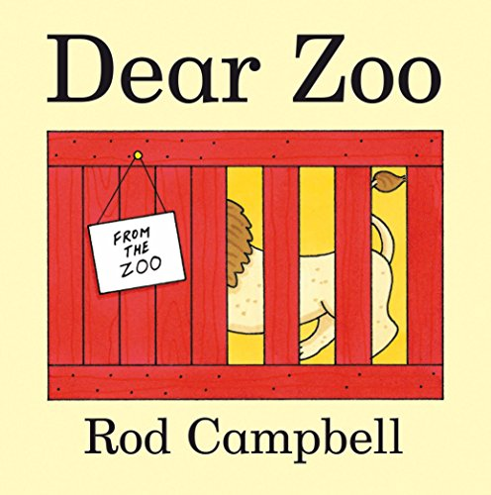  - Can you remember which animals were sent from the zoo in the story? There were 8 altogether  - Have you got a favourite animal? Can you describe it? Is it big or small? Where does it live? Why do you like it? Record a short video – we would love to see you talking about your favourite animal | Sound of the week – ‘c’  - Continue to practise the sounds we have learnt so far. Watch Mrs Goodfield’s sound video again from last week. Can you remember them all? In school we spend 5 minutes going through the sounds cards every day  - Watch the sound of the week video. Can you make your own silly soup with ‘c’ items around your house?  - ‘C’ - Say the rhyme as you write – curl around the caterpillar  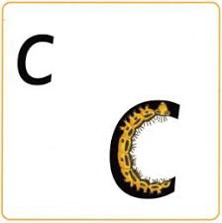  - Have a go at forming a ‘c’ yourself using foam, flour, sand….anything messy! | Mathematics  - Watch the separate video of Mrs Kumar counting along using a number line. Can you count along too? Did you spot the missing number? In school we count using a number line every day. We count forwards and backwards to 10, then challenge ourselves counting forwards to 20. Make your own number line at home and ask an adult to hide a number - can you work out which one it is?  - Focus on forming the number ‘1’ carefully. Use our rhyme to help you.  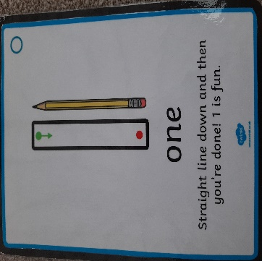  - If you are really good at recognising the number 1, counting out 1 object and writing number 1, you could really challenge yourself by writing ‘11’ and counting out 11 objects.  - In the story, the snake was too scary. Use the separate snake sheet to make a repeating pattern. Try a simple two colour pattern to start with (red, blue, red, blue). If you are good at this, try using 3 colours (red, blue, yellow, red, blue, yellow).
The 3 boxes below are some suggested extra activities to complete.
Please take some pictures so that you can share what you have been doing with us!

Knowledge and Understanding  - In the story, the animals had to travel in special containers to keep them safe. Can you make some containers for moving the zoo animals around? You could use any construction toys you have at home (Lego, Knex, etc.) or you could use cardboard, old containers for recycling…we would love to see your ideas  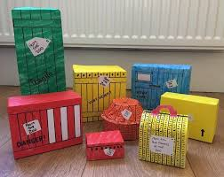 | Imaginative Play  - Animals at the zoo need to be kept clean. Click on the link below to see how zoo keepers in one zoo clean the elephants  https://www.youtube.com/watch?v=7bsw6RrMQtw  - Have a go at washing, scrubbing and cleaning some of your own animals. You could use an old toothbrush or a small cloth and lots of bubbles!  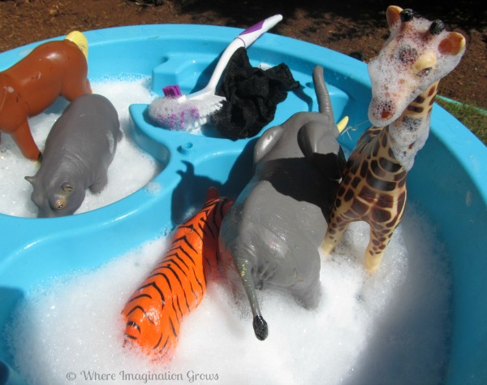 | Cymraeg  - Watch the separate video of Mrs Kumar introducing welsh phrases linked to the weather. Can you join along and say them too? In school we would read these cards every day to help the children to memorise them. We will be adding more cards and actions next week.

