**Summer Term 2016 Year 1**

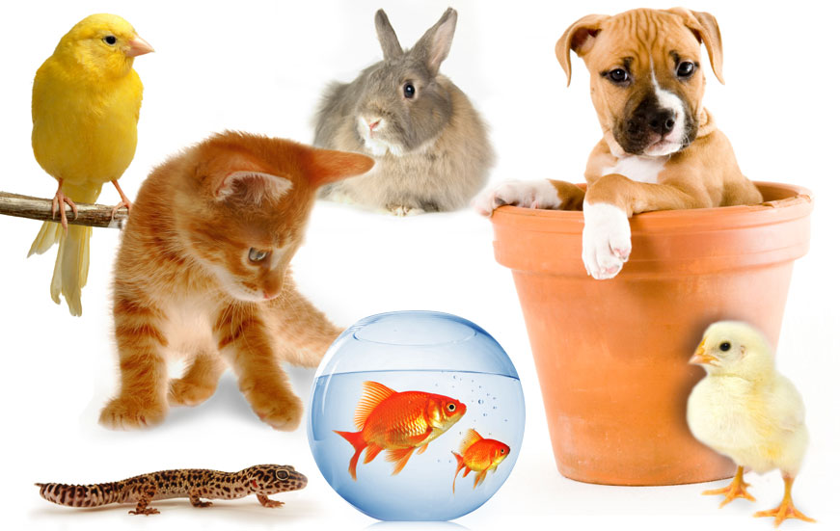

Dear Parent

Welcome back to the new school term, and I hope you all had a super Easter holiday. This term our topic is Mini Zoo. The children will be learning about different animals, their life cycles and what they need to stay alive and be well.

The children will be learning:

* About the habitats of domestic and wild animals
* Why animals are important to us and how we care for them
* About organisations and people who look after animals
* How to make a simple map or plan
* How to solve simple money problems
* How to use the internet and books to find information

The role-play area will be transformed into a Pet shop and the children will work together in the making of props and posters to aid their play. We will also introduce an incubator into the classroom containing chicken eggs; to give the children hands on experience and the opportunity to observe change and growth for themselves. I would also like to bring my pet budgie ‘Grass’ into the classroom for this term but if your child has any allergies to pet fur/feathers, please see me ASAP.

**Cefn Mably Farm Park – Friday 22nd April**

The class are really looking forward to our trip. Please ensure your child is wearing sensible shoes or trainers and brings a packed lunch and plastic drinks bottle.

**Reading** Please remember that if your child has completed their books before the designated reading day and you have written a comment on their reading card, they will be able to take another book of their choice home.

**Homework** I would like to take this opportunity to thank you for your continued support in ensuring homework tasks are completed to a high standard and submitted on time. Please note homework files are handed out every Friday and your child is informally tested on their spellings every Thursday. Therefore please keep homework files until the following Thursday so that they have plenty of time to practice.

Thanks again for your continued support.

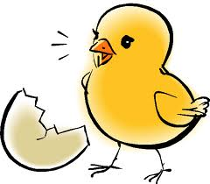

#### Mrs Sarah Trigg

Class Teacher