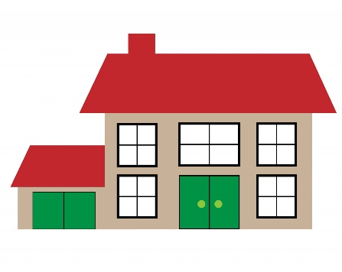
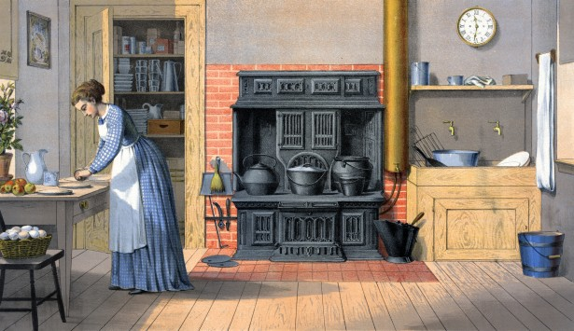

Spring Term - Year 2

Dear Parent,
We hope you all had a lovely Christmas break.

This term’s topic is ‘Home Sweet Home’ and we have many exciting experiences planned. We will be learning about our homes today and how families lived in Victorian times. We will also find out about famous inventors and how these inventions have changed daily life. After half term the focus will move to school life then and now.

Please visit ‘Meet the Classes’ on our website: llanfairps.com for class information and check the ‘shared’ folder on HWB for more photographs.

Reading
Your child will continue to bring home a folder containing two Oxford Reading Scheme books and a comment card. This folder will be sent home on a fortnightly basis beginning Friday 14th January.

Homework
Homework tasks will be shared with parents at the start of each half-term using a Homework Grid. Please see the reverse of this letter. This system has proven to be very successful in Key Stage 2.

Spelling – Year 2
New spelling words will continue to be sent home on a Monday in a blue spelling book. During the week, your child can practice writing the words on the same page.
Please return spelling books to school on Monday of the following week for an informal test. (The test will be recorded at the back of the blue spelling book).

P.E.
P.E. every Wednesday. Please ensure your child comes to school in their PE kit. If there is any reason why your child should not be participating in P.E. lessons (due to illness/injury) please could you let me know.
Thank you for your support,

Mrs Sarah Trigg

Class Teacher

