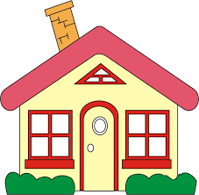

Spring Term - Year 1

Dear Parent,
We hope you all had a lovely Christmas break.

This term’s topic is ‘Home Sweet Home’ and we have many exciting experiences planned. We will be learning about our homes today and how families lived long ago, different types of houses and how houses are made.

Please visit ‘Meet the Classes’ on our website: llanfairps.com for class information and check the ‘shared’ folder on HWB for more photographs.

Reading
Your child will continue to bring home a folder containing two Oxford Reading Scheme books and a comment card. This folder will be sent home on a fortnightly basis beginning Friday 14th January.

Homework
Homework tasks will be shared with parents at the start of each half-term using a Homework Grid. Please see the reverse of this letter. This system has proven to be very successful in Key Stage 2.

Spelling – Year 1
New spelling words will continue to be sent home every Monday on an A4 sheet. During the week, your child can practice writing the words on the sheet in preparation for an informal test on Monday of the following week.

P.E.
P.E. every Wednesday. Please ensure your child comes to school in their PE kit. If there is any reason why your child should not be participating in P.E. lessons (due to illness/injury) please could you let me know.

Thank you for your support,
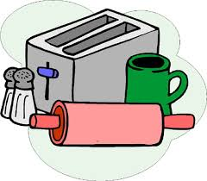

Mrs Sarah Trigg

Class Teacher

