Spring Term - 2020 (Year 3/4)

Dear Parents,

Welcome back to an exciting Spring term in Year 3 and 4.

This term’s topic is ‘Global Gourmet’. This project teaches children about different food types from around the World, fairtrade and the importance of eating a healthy diet for wellbeing.

In this project the children will learn:
• Where food originates from, and how food has a ‘carbon footprint’ which affects the cost;
• About the cultural traditions relating to food; how food production is important to particular countries;
• How diet affects our health and wellbeing;
• To make accurate measurements and calculate costs of food and ingredients;
• To develop basic food technology skills and follow recipes;
• How to write letters for a range of purposes both formally and
informally.

Reading
Year 3 pupils will now move onto our KS2 Guided Reading programme. Please see additional letter for more information. (However, if you would like to continue using school scheme books as home readers please let me know and I will set up a folder and reading card.)

Spelling
The children will continue to bring their spelling book home to practise words each Monday. Please return the book on Friday of the same week for testing.

Homework
‘Learning Logs’ will continue to be given out on a Friday and are due back by the following Wednesday. Please ensure that a pencil is used to complete this work and that pens are only used for colouring activities. I would like to take this opportunity to thank you for your continued support in ensuring homework tasks are completed to a high standard and submitted on time.

P.E.
Sessions will be every Thursday and Friday. Please ensure that your child’s name is clearly marked on all their items of clothing. If there is any reason why your child should not be participating in P.E. lessons (due to illness/injury) please could you let me know.

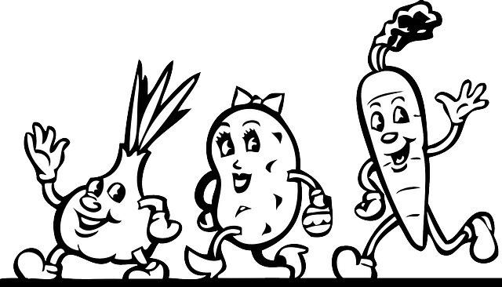
Thank you in advance for your support.

Mrs Sarah Trigg
Class Teacher

