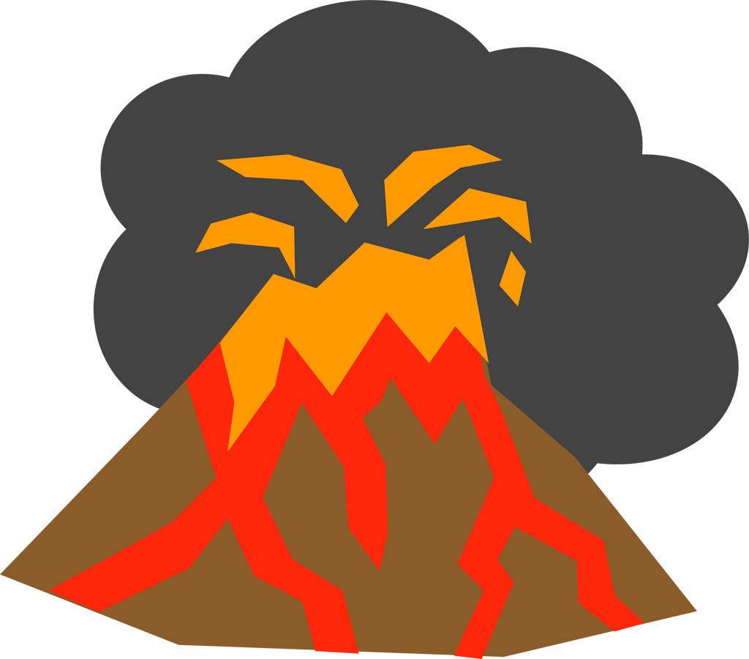
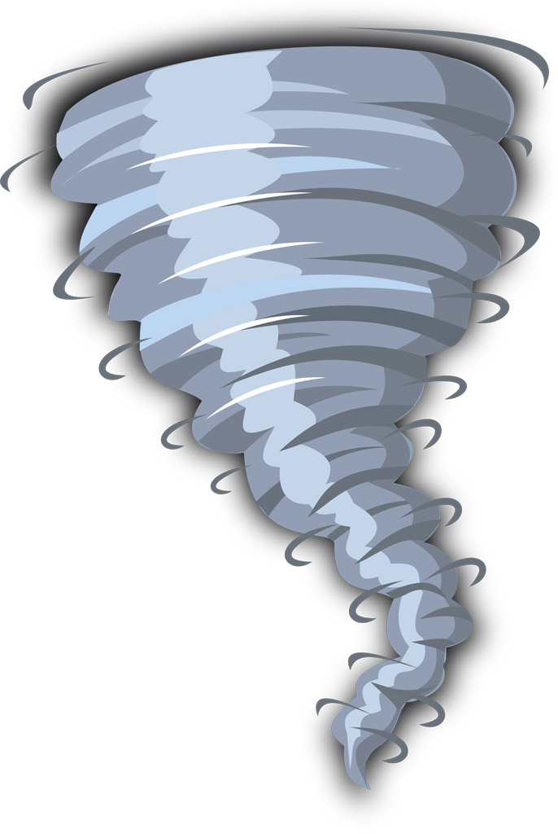

Spring Term - 2019 (Year 3/4)

Dear Parent

Welcome back to an exciting Spring term in Year 3 and 4.

This term’s topic is called 'Earth, Wind and Fire’. This project has a geography focus and teaches children about the causes and impact of natural disasters and extreme weather. If you have any books or items that you feel would help resource our project, we would be very grateful if you could send them into school with your child.

Reading
We are currently reviewing our reading scheme and how we listen to readers in Key Stage 2. More information about these changes will be sent out in a separate letter from Mr Guy. In the meantime, your child’s reading day will be on ______________________.

Spelling
The children will continue to bring their spelling book home to practise words each Monday. Please return the book on Friday of the same week for testing.

Homework
‘Learning Logs’ will continue to be given out on a Friday and are due back by the following Wednesday. Please ensure that a pencil is used to complete this work and that pens are only used for colouring activities. I would like to take this opportunity to thank you for your continued support in ensuring homework tasks are completed to a high standard and submitted on time.

P.E.
Sessions will be every Tuesday and Friday. Please ensure that your child’s name is clearly marked on all their items of clothing. If there is any reason why your child should not be participating in P.E. lessons (due to illness/injury) please could you let me know.
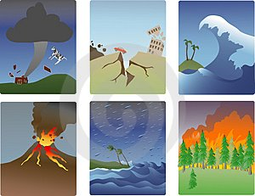
Thank you in advance for your support.

Mrs Sarah Trigg
Class Teacher

