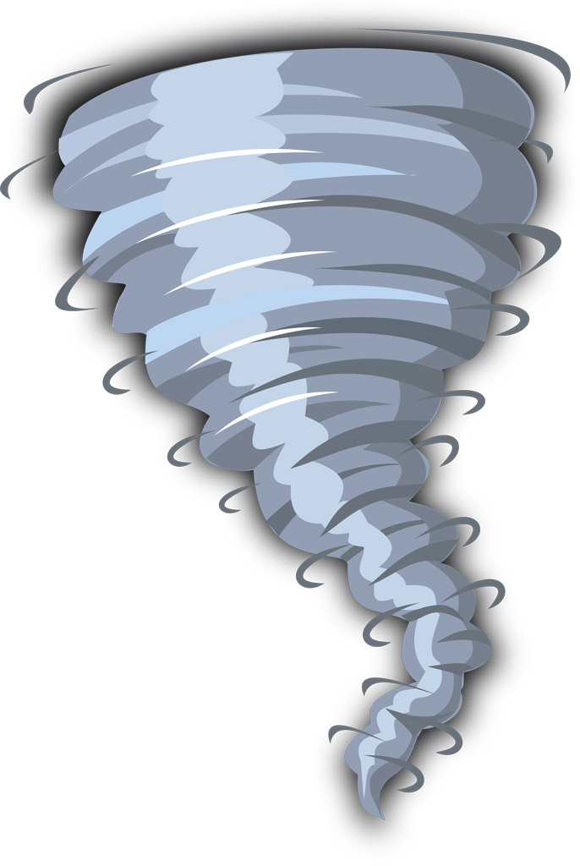

Spring Term - 2017 (Year 3/4)

Dear Parent

Welcome back to an exciting Spring term in Year 3 and 4.

This term’s topic is called 'Natural Disasters’ and we have many exciting experiences planned. The role-play area is being transformed into a ‘Newsroom’ and the children will work together in the making of props and posters to aid their learning. If you have any books or items that you feel would help resource our project, we would be very grateful if you could send them into school with your child.

Reading
Just a reminder, your child’s reading day is ……………………………………………………
Please send in your child’s reading folder into school on this day. These books need to be returned to school with reading books on a weekly basis.

Spelling
The children will continue to bring their spelling book home to practise words each Monday. Please return the book on Friday of the same week for testing.

NB: It is imperative that this book is brought in on the Friday.

Homework
‘Learning Logs’ will continue to be given out on a Friday and are due back by the following Wednesday. Please ensure that a pencil is used to complete this work and that pens are only used for colouring activities. I would like to take this opportunity to thank you for your continued support in ensuring homework tasks are completed to a high standard and submitted on time.

P.E. – Change of day
Sessions will be every Monday and Thursday. Please ensure that your child’s name is clearly marked on all their items of clothing. If there is any reason why your child should not be participating in P.E. lessons (due to illness/injury) please could you let me know.
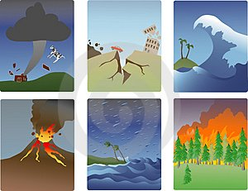
Thank you in advance for your support.

Mrs Sarah Trigg
Class Teacher

