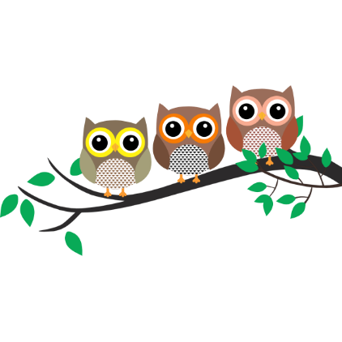

Spelling Information Sheet

Spelling – Year 2
Spellings will focus on the ‘Sound of the week’ and high frequency words.

- Every Monday, weekly spellings will be stuck into the front of your child’s blue spelling book. If your child has forgotten their book, please look out for a paper copy in their bag or lunchbox.
- During the week, your child can practise writing the words on the same page or try activities from the Spelling Menu below.
- On Friday, please return the blue spelling book to school for an informal test. (The test will be recorded at the back of the book).

Spelling Menu

Here are some fun ideas to help your child learn their weekly spellings

Rainbow Words  Write your spellings with coloured pencils. Make each letter a different colour. | Pyramid Words  s  sh  she  shee  sheep | Wordsearch  Create your own wordsearch with your spellings. | Flashcards  Make and practise with flashcards. Put the word on one side and definition on the other
Roll it!  Choose six spelling words. Number each word (1-6). Roll a dice and write the word. Repeat until each word is recorded 3 times. | Use Technology  Type out your spelling words on the computer. Try to use different fonts. | Train words  Write the entire list end-to-end as one long word. Write each word in a different colour.  e.g. shopsheepshot | Picture Words  Draw a picture and hide your spelling words in the picture.

Thank you for your continued support,

Mrs Sarah Trigg

Class Teacher

