A Spelling Guide for Parents

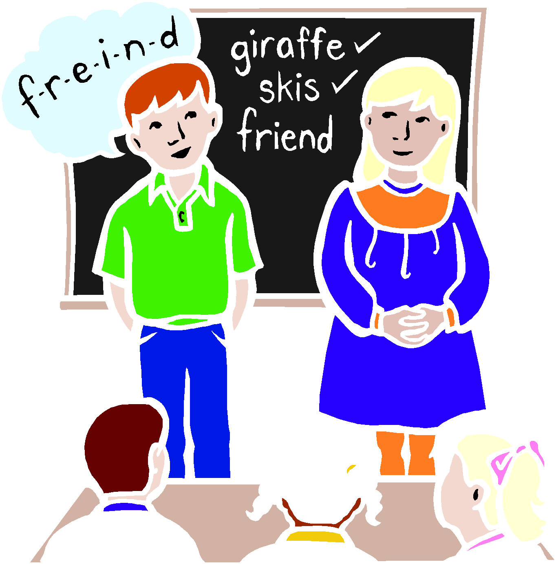

A SPELLING GUIDE FOR PARENTS

Children will be learning important key words and words with regular spelling patterns as part of their Language and Literacy/English lessons.

In the Foundation Phase, spelling is part of the progression in learning phonics and therefore links closely to learning to read.
These pupils are engaged in a number of activities including puzzles and games and early writing activities matching sound to letter shape. Early high frequency words are also taught.

In Year 1 and 2 the learning of high frequency words continues and pupils begin to learn how to spell simple CVC words (cat, pot, cup etc), spell simple words starting with initial consonant clusters (br, bl, cr, cl etc) and words following spelling patterns for vowel phonemes (ee, eaie, oo etc)

In KS2 pupils progress to learn letter strings, word families, root words, suffixes, prefixes and words relating to subject topics.

Children in all classes are taught strategies to help them to learn independently. These involve learning by sight, sound, movement, making trials and using the Look, Say, Cover, Write, Check method. Wordcards, spelling mats, word walls and lines are also used containing high frequency words.

Children’s written work is sensitively marked to enable all aspects of their writing to be appraised including punctuation, content, structure and use of interesting vocabulary along with spelling. We recognize that children pass through a series of stages in learning to spell and teachers’ assessment of individuals’ work including spelling inaccuracies are addressed accordingly.

Tests take place within the classroom as a form of on-going assessment to inform future planning.

Children will bring home spelling lists associated with spelling patterns, topic words or medium / high frequency words. We recognize that parents have an active part to play in all aspects of their children’s learning and can specifically help them to learn to spell.

IN HELPING YOUR CHILDTO SPELL REMEMBER

Do

Talk to them about how words are made up.

Tell them to look carefully at words and think of others containing the same pattern.

Train them to visualize words with their ‘eyes shut’.

Encourage them to Look, Say, Cover, Write, Check when learning a word.
Make sure they write words from memory–don’t copy a letter at a time.
Write down ‘asked for ’words and remove them before they write.
Help them with handwriting– correct formation of letters and encourage a
good pencil grip.

Encourage them to be careful.

Praise them for all attempts and give lots of encouragement.

Don’t

Let learning to spell become rote learning.

Think that ‘seeing’ a word is the same as ‘looking ’at the word.
Allow them to copy letter by letter

Allow them to form letters incorrectly or develop an incorrect pencil grip.
Get worried about mistakes they might make.
Let them think they are poor spellers.

Many Thanks: Mrs H Mayes and Miss H Jones

