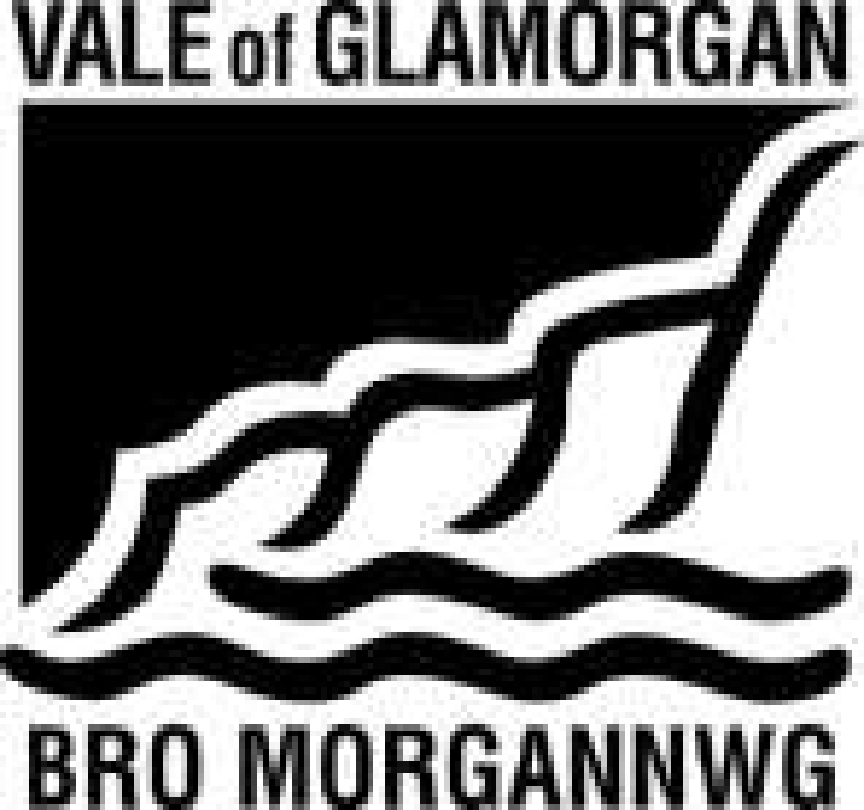

RISK ASSESSMENT - COVID 19 moving from Pandemic to endemic

Location/Premises/School: Llanfair Primary School | Date: September 2021 V2.
Completed by: JP Guy | Review date: as and when required e.g. issues identified, changes in Welsh Government / Public Health advice etc
Activity/Description/Area:

This model risk assessment has been drafted taking into account the level 0 and the move from pandemic to endemic and all the information that is currently available including the following Welsh Government coronavirus guidance:

https://gov.wales/operational-guidance-schools-and-settings-1-september-2021-html

This will be replaced on 20th September 2021 with the

https://gov.wales/written-statement-local-covid-19-infection-control-decision-frameworks-schools-and-colleges-autumn?utm_source=rss-topics-Coronavirus+%28COVID-19%29&utm_medium=rss-feed&utm_campaign=rss-Written+Statement%3A+Local+COVID-19+Infection+Control+Decision+Frameworks+for+schools+and+colleges+from+autumn+2021

The approach set out in the Frameworks should be adopted as soon as possible after the start of term, and by 20 September 2021 at the latest

The guiding Principles are:

- enable schools to operate as ‘business as usual’ as far as possible including the provision of free breakfast and after school clubs, extra-curricular activities and practical subjects
- secure the best outcomes for all learners by considering both their educational needs and wellbeing
- manage Ongoing risks of COVID-19 as safely as possible as for other infections, and ensure clarity of actions required if there is a case in a school

This risk assessment should be read in conjunction with the school’s generic risk assessment.
Please note that school also holds a risk assessment on live streaming.
Policies are available in the staffroom on:
- Safeguarding
- Behaviour management
- E-safety
- Data Protection

The EWC code of conduct is available in the staffroom. The school also holds a blended learning plan.

What are the hazards? | Who might be harmed and how? | What are you already doing? | What further action is necessary? | Action by whom | Action by when | Date action completed
Spread of Coronavirus | Staff & pupils  Not following Welsh Government guidance | Anybody unwell with symptoms of COVID-19 will stay at home:  - New continuous cough;  - High temperature;  - Loss of/change in taste or smell  No pupils/staff to attend school if they:  - Feel unwell, have any of the above symptoms or have tested positive to COVID-19 in the past 10 days;  - If a member of the immediate household tests positive for Covid 19 a PCR test should be undertaken and then only self-isolate if the test is positive but staff/pupil will take a cautious approach and be mindful of any potential symptoms  Anyone (staff or pupils) who have any of the wider symptoms of COVID-19 (fatigue, myalgia, sore throat, headache, sneezing, loss of appetite, nausea, vomiting and diarrhoea) should seek a PCR test.  Robust hand and respiratory hygiene including ventilation.  Those eligible will have been offered double vaccination.  Continue with the regular cleaning arrangements during the day and at the end of the school day.  Active engagement with Test, Trace, Protect.  Consideration how to maximise distancing between those in school wherever possible and minimise potential for contamination.  Encourage the use of outdoor learning spaces.  Visitors to the school - records kept of who has visited and when.  All permitted visitors including parents who access the school site will wear a face covering in line with school policy. | Ongoing monitoring | All Staff | Ongoing
Prevention of Coronavirus | Staff & Pupils | Regular communication with staff, parents, guardians.  Minimise contact between individuals as reasonably practicable:  - No larger group indoor activities eg live assemblies/concerts for the short term;  - It is recommended to maintain traffic routes around the school;  - No parents on yard at drop off and collection with the exception of nursery  - Transient contact is not such an issue;  - Slightly staggered approach to lunchtimes in the first instance.  Process in place for removing face coverings by those that use them when they arrive at school – don’t touch the front of the mask, place mask in covered bin (reusable masks into a plastic bag that can be taken home with them), wash hands.  Staff will be able to undertake twice weekly lateral flow testing and communicate results to HT/Admin prior to attending school.  Cleaning hands thoroughly more often than usual with soap & water/hand gel – on arrival at school, returning from breaks, toilet visits and before/after eating.  Good respiratory hygiene by promoting ‘catch it, bin it, kill it’.  Continuing with enhanced cleaning until the end of September. Frequently touched surfaces & outside equipment will need to be cleaned  Wearing appropriate PPE (see below).  Ensure appropriate ventilation.  Within classroom:  - Make small adaptations to the classroom to support minimal face-to-face contact where possible, including sitting side by side;  - Move unnecessary furniture out of classrooms to give more space;  - Maintain a distance & reduce the amount of time they are in face-to-face contact  - Where possible adults to maintain social distance from each other and from pupils;  - Staff to avoid close face-to-face contact and minimise time spent within 1 metre of anyone.  - Additional hand sanitising stations  - Hand washing posters on display  - Social hygiene skills e.g. using / disposal of tissues, face touching etc. to be reinforced throughout the day;  Elsewhere:  - Separate playtimes and separated areas at lunch for contact groups in the first instance.  - Avoid large gatherings such as assemblies;  - Traffic routes will be used;  - Avoid creating busy corridors, entrances and exits;  - Additional staff spaces set up to avoid using small communal areas eg social distancing will be maintained in staff rooms. Nursery space will be used by staff for lunch as well as staff room space.  - Parents asked to inform school of any external child care provider they are using to allow for liaison and effective tracking.  - Each class has a separate tea/coffee station  - Photocopier to remain in the hall in the first instance.  Key stage two pupils will have their own individual and very frequently used equipment such as pens and pencils that are not shared.  Classroom-based resources such as books and games can be used but they should be cleaned regularly. | Staff to wear masks in communal areas/staff room corridor where physical distancing cannot be maintained.  Ensure sufficient hand washing / hand gel ‘stations’  Supplies of tissues & bins available in all classes  Toilets will be shared by different groups however, pupils will wash hands prior to entering the toilet and when leaving the toilet & ensure toilets will be cleaned regularly throughout the day.  Encourage parents to ensure their children wash hands thoroughly before attending school.  Resources that are shared between groups such as sports, art and science equipment should be cleaned frequently | Head  Teacher  All Staff  Head Teacher  Head Teacher  Head Teacher  Staff | Ongoing  Ongoing  Ongoing  Ongoing
Asymptomatic staff /pupils at the school | All staff | Lateral flow tests available to all staff working in primary setting/schools.The only exception is staff who have tested positive for Covid 19 will not be able to take a lateral flow test for 90 days from their positive result.  Lateral flow test kits will be offered to all schools and settings in order for staff to take twice weekly tests. Testing is voluntary, but staff are encouraged to participate to further reduce the risk of asymptomatic transmission within the workplace. Testing is recommended on a Sunday evening and a Wednesday.  Anyone who tests positive using a Lateral Flow Test (LFT):  - will not attend setting or school and will inform the school immediately so that all contacts can be warned and informed.  - Will log the result via the on-line form  - A follow up PCR test will be booked  - if the result of the PCR is positive the school will email to inform them there is a positive at the school  SuperTracers@cardiff.gov.uk  ttpcvschools@cardiff.gov.uk  and  COVID-19Enquiries@valeofglamorgan.gov.uk | School SLT will continue to monitor the process and will support any staff with queries. | All staff
Incorrect Use of PPE and face coverings i.e. exposure to the virus inadvertently | Staff & pupils | Social/physical distancing, hand hygiene and respiratory hygiene remain the most effective ways to prevent the spread of coronavirus.  Staff can choose to use (surgical face masks) when undertaking routine education activities in the classroom/school setting if social distancing cannot be guaranteed.  If a pupil becomes unwell with symptoms of COVID-19 and needs direct personal care, staff will wear disposable gloves, apron and fluid-resistant (type IIR) surgical mask; eye protection should also be worn if a risk assessment determines that there is a risk of splashing to the eyes from coughing, spitting or vomiting; gloves and aprons to be worn when cleaning areas where a symptomatic person has been.  All the above PPE to be worn if providing intimate care.  Any visitor to the school will wear a face covering and sign the visitor register in line with school policy. Visitors will wear a face covering where distancing cannot be maintained.  Parents will be asked to wear a face covering when on the school site.  Staff can choose to wear surgical mask face coverings when dealing with upset children at the beginning of the day as staff might need to get close to parents/carers in this instance. | Staff to wear masks in communal areas/staff room corridor where physical distancing cannot be maintained.  Provide staff with a supply of single-use face coverings or washable face coverings | All Staff  Head Teacher | Ongoing  Ongoing
People at school who are unwell | Staff & pupils possibly visitors | Pupils who develop Covid symptoms are to be placed in the spare classroom space or outside until they are collected, supervised at a distance of 2 metres where possible. If this is not possible, disposable gloves, apron, disposable mask type IIR & visor to be worn.  Anybody with the three main Covid symptoms to stay at home, begin to self-isolate for 10 days and make arrangements to be tested ASAP (including pupils).  Engage with the Test, Trace, Protect strategy.  All staff will be able to undertake twice weekly ‘lateral flow tests’, communicating results to HT/Admin Staff prior to attending school.  Manage confirmed cases of COVID-19 among the school community and contain any outbreak by following local health protection team advice.  Thoroughly clean the areas used by the unwell child/staff member. | Ensure surfaces that symptomatic pupils / staff have come into contact with are carefully and thoroughly cleaned  If test is negative, they can return to school when they feel well enough to do so  Advise H&S Team as soon as anybody in the school tests positive | Staff  Staff / pupils  Head Teacher  Line manager | Ongoing  Ongoing  Ongoing  Ongoing
Engage with the Test, Trace, Protect (TTP) Strategy to avoid the spread of the virus | Staff & pupils | School will remind everybody who is showing symptoms to self-isolate and book a test. Those living with someone showing symptoms will also self-isolate, get a test and then will take a cautious approach if negative  The Test Track Protect team will work with the school to identify which pupils will need to be tested or may need to be warned and informed following a positive case linked to the school. Warn and inform letters are only sent to contacts  Record of visitors | School will be contacted by the TTP team to assist in tracing contacts where necessary | Head Teacher | Ongoing
Pupils & staff with underlying health conditions | Staff & pupils | Staff and pupil well-being is a primary concern for the school.  Support mechanisms for staff include:  - Talking to line manager;  - Completing the All Wales Covid-19 workforce assessment tool;  - Employee Assistance Programme (Care First) available 24/7 on 0800 174 319;  - Occupational Health Service can be contacted on https://staffnet.valeofglamorgan.gov.uk/Staff-Central/Human-Resources/Occupational-Health/Referring-to-Occupational-Health.aspx  Staff to be alert to identify and support learners who exhibit signs of distress. | Monitor Welsh Government advice for any additional action to be taken in relation to those that were shielding.  Support can be obtained from the H&S Team and / or the OH Service  Staff to use the COVID-19 Workforce Risk Assessment (self-assessment) to consider their own health and well-being status to see if they are at higher risk of developing more serious symptoms if they come into contact with the COVID-19 virus – result will be either low, high or very high. Result to be discussed with the line manager.  Well-being action plan for any staff who require reasonable adjustments | Head Teacher  Any staff that choose to | Ongoing
Transport – spread of the virus during commuting to school | Staff & pupils | If staff are sharing a vehicle, they will take reasonably precautions i.e. socially distance, use of face covering and ventilation.  Face coverings will be worn on all school transport and the risk assessment provided will be followed |  |  | Ongoing
Lack of First Aid provision or transmission of the virus via the application of first aid | All staff & Pupils | Low risk environment.  Supervision ratios to be adhered to (minimum of emergency first aid staff on site at all times).  First aid equipment available and adequately stocked. Hygiene will be maintained throughout the first aid process  Corporate accident / incident form to be completed where appropriate. | All first aid trained staff will keep up to date with latest government guidance on first aid. |  | Ongoing
Administering prescription medication  Incorrect medication or dosage given; medication not available | Pupils | Usual school policy / procedures to be followed by staff hygiene and PPE worn as required. |  |  | Ongoing
Fire breaking out | All staff & pupils  Burns, smoke inhalation, asphyxiation | Fire alarm checks to be carried out as normal  Fire doors should not be wedged open unless done so with an appropriate hold open device that is connected to the fire alarm system.  Head Teacher will ensure fire risk assessment is up-to-date and any outstanding work undertaken  Fire evacuation procedures and drills undertaken | Support can be obtained from Fire Safety Officer on 01446 709150 |  | Ongoing
Safeguarding issues due to the Covid 19 situation | Pupils | All staff aware of their safeguarding duties.  All staff and pupils should know how to contact the Designated Safeguarding Person (DSP) and consider how pupils can talk privately (spare classroom or HT office).  Standard procedures to be observed including consideration of older age groups.  Appropriate site security arrangements in place. |  |  | Ongoing
Breaches of  Building & property maintenance | All staff & pupils  Legionella, defects in property, faults, electric shock etc. | All routine inspections & tests must be maintained e.g. legionella water monitoring, hand wash water temperatures.  Statutory inspections & servicing to continue.  Defects to be reported for remedial action.  All doors to chemical / cleaning storage, electrical distribution cupboards, high risk areas etc. to be kept locked.  Good housekeeping to be maintained.  All outdoor building maintenance must be coordinated with the Head Teacher to ensure segregation from pupils and staff e.g. grass cutting.  All contractors report to reception prior to the start of any work and will follow the school procedures. |  |  | Ongoing
Cleaning so that the virus does not spread | All staff & pupils | Maintain robust cleaning at all times.  Wash hands following any cleaning activity.  Cleaners to wear appropriate PPE in line with current arrangements e.g. gloves, apron etc.  Wear goggles if decanting chemicals where there is a risk of splashing in the eyes.  Staff to assist with cleaning where appropriate.  COSHH information on cleaning products.  COSHH slide deck for staff. | The school will be aware of the provision for cleaning supplies from the Vale and the removal of additional funding so will manage cleaning resources to ensure that a robust approach is followed. |  | Ongoing
Lack of staff, reduction in supervision | Staff & pupils  Lack of supervision, increase in accidents, increase contact | Maintain supervision levels as far as practicable at all times.  Identify back-up staff from both within school and a supply agency.  Utilise rotas to cover access times including break and lunch times. Consider redeploying staff where necessary. | Head Teacher, SLT, Admin  To be continually monitored. |  | Ongoing
Catering – spread of the virus during meal times | Staff and pupils | Kitchens will be fully open.  Pupils will eat school dinners in the canteen – pupils will be seated in contact groups initially.  Tables and points of contact will be cleaned.  There will be good ventilation.  Staff will socially distance | Further information and guidance provided by Welsh Government to cover any potential issues with the provision of free school meals, if the need arises  Staff to wear masks in communal areas/staff room corridor where physical distancing cannot be maintained.
Spread of the virus during Educational visits | Pupils/ staff | Welsh Government supports the guidance produced by a partnership of experts to help ensure that educational visits and activities are safe: https://oeapng.info/.  Specific risk assessment will take Covid 19 into account especially if visits involve transport when precautions will be undertaken. | EVC Coordinator
Breakfast Clubs & after school provision
Spread of Coronavirus |  | - Parents will be able to book up to 5 sessions in advance  - Allotted time for arrival for pupils to avoid high levels of on site traffic  - Pupils will sit in contact groups, distanced from other contact groups |  | HT | 21 Sept | 21 Sept 20
Transmission via inanimate objects | Staff and pupils | - ‘High touch’ areas will be cleaned more frequently using standard cleaning products such as detergents.  Please note in primary schools’ plastic toys should be cleaned using Milton and not the veridical spray.  - Each contact group will have their own activity tray  - Tables will be cleaned before and after use by the contact group |  | BP staff | Ongoing
Person to person transmission | Staff, pupils and parents | - Staff to try and maintain 2m distance from pupils where possible and to avoid close face to face contact  - Breakfast will be served at table to avoid pupils moving around  - Parents will not enter the building; pupils will be signed in by member of staff  - Parents reminded to use the one-way system |  | BP staff  Parents | Ongoing
Lack of staff, reduction in supervision | Pupils | - Ratio of staff to pupils is higher than required due to lower pupil numbers  - HT to support if required  - Temporary closure of provision | Inform parents of the need to close provision | HT | Ongoing
Music Lessons – restarted 29th April 2021

Person to person transmission | Staff and pupils | - Tuition groups to be from same contact groups so pupils are not crossing bubbles.  - Pupils need to use their own instruments, no sharing  - Peripatetic teacher to adhere to Cardiff and Vale Music Service risk assessment and school’s risk assessment.  - Designated space in the canteen which can be fully ventilated.  - After school club use the space following the tuition. Sufficient time has been left for the space to be cleaned accordingly and to avoid staff crossing/accessing the space at the same time. |  | HT/Music Service | Ongoing

