Llanfair Primary School

Enjoy, Learn, Achieve
Mwynhau, Dysgu, Llwyddiant
School Prospectus

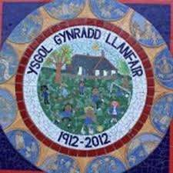

Headteacher / Pennaeth: Mr. R N Jones
Deputy Headteacher / Dirprwy Pennaeth: Miss H. Jones
Chair of the Governing Body: Mrs. M. Nelson

Welcome

It is my pleasure to present the prospectus for Llanfair Primary School. Llanfair is an English medium, co-educational primary school with attached nursery, for children from 3 to 11 years of age. We are situated in the hamlet of The Herberts, adjacent to St. Mary’s Church, surrounded by stunning countryside views.

We provide a caring environment and a wide range of balanced learning opportunities for all children, to help them grow into independent and responsible people, well prepared for the next step in their school lives.

We believe that close co-operation between home and school is essential for children’s social and academic development. My staff and I are always available to talk to you about any aspect of your child's development.

Should you wish to discuss any area described within our prospectus further, please do not hesitate to contact school.

Mr. R N Jones
Headteacher

School Aims

At Llanfair Primary we aim to:

- Have high expectations where everyone strives to do their best.
- Encourage children to think, ask questions and be creative through challenging, interesting and fun learning.
- Ensure each child is successful; ready to learn throughout their lives and flourish in the future.
- Develop each child’s resilience, self-belief and confidence to seek out, relish and overcome challenges.
- Develop caring, considerate and compassionate children, with a strong sense of belonging and heritage, who use their power positively to change the world.

Contents:

Section 1: Contact details and location p 4

Section 2: Admissions p 6
(Inclusive of secondary school arrangements)

Section 3: School Day Organisation p 7
(Inclusive of times, uniform, school dinners).

Section 4: Curriculum and Teaching p 13
(Inclusive of homework, P.E., R.E. and Collective Worship).

Section 5: Safeguarding and Site Security p 17

Section 6: Additional Information p 17

Section 1: Contact details and location

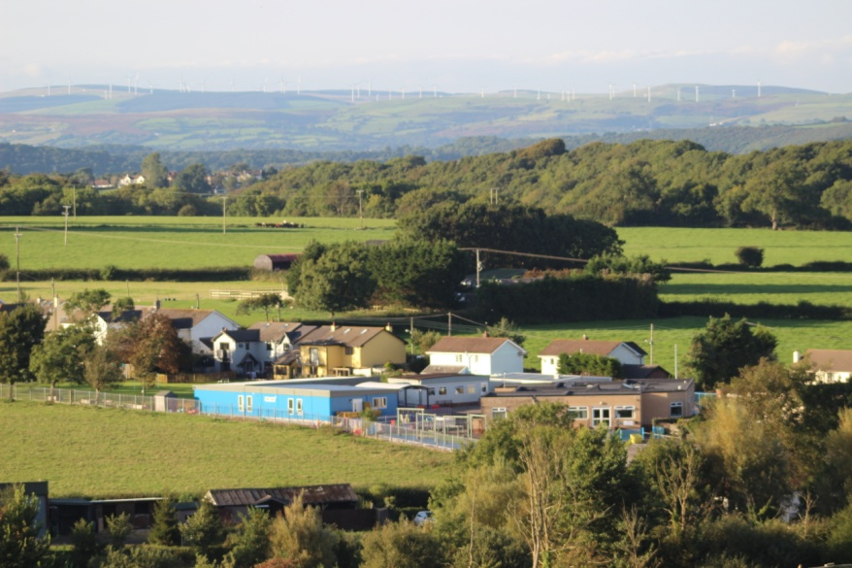

The Herberts, St Mary Church

Cowbridge,

Vale of Glamorgan.

CF71 7LT

Tel: 01446 772245

Email: LlanfairPS@valeofglamorgan.gov.uk

www.llanfairps.com

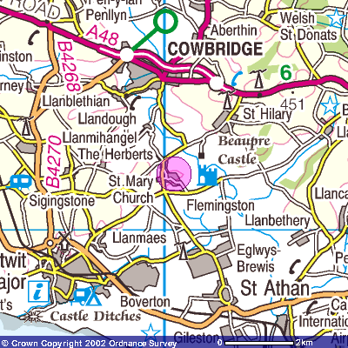
A Satellite Navigation system will take you to the Church in the main village of St. Mary Church; the school is not in the main village, it is in the hamlet sign-posted The Herberts.

At The Herberts, take a left turn on the corner of the right hand-bend. A sign indicates the school’s location.

Our school community

Class teachers  Mrs. Gaisford  Miss Jones  Mrs. Kumar  Mr. Lewis  Mr. Marshalsay  Mrs Norris  Mrs. Mayes  Mrs. S. Trigg | Governors  Mrs. N Sturges – Clerk  Mrs. M. Nelson – Chair  Mrs. C. Neuddeg – Vice Chair  Mrs. B. Wostear  Mrs. M. Llewellyn  Mr. G. Smith  Mr. S. Trigg  Mrs. S. Trigg - Teacher representative  Mr. A. Crowe  Miss. R. Edwards  Mrs. H. Wickett  Mr. R. Fisher  Mrs. S. Rees/Miss. J. Walker - Non-teaching Representatives  Mr D Davies (observer)
Learning Support Assistants
Mrs. Davies
Mrs. Evans
Miss Jones
Mrs. Rees
Miss Walker
Mrs. Earey
Ancillary Staff
Miss J. Jackson – Administrative Officer
Mrs. S. Rees– Administrative Officer
Mr. M. Thomas – Caretaker
Mrs. Cook– School Cook
Mrs. Gilvear – Breakfast/Kitchen
Mrs. Duncan - Breakfast
Miss Walker – Breakfast/Mid-day Supervisor

Section 2: Admissions

Application to attend Llanfair Primary School is through the Vale of Glamorgan Local Education Authority, address:
Civic Offices,
Holton Road,
Barry,
CF63 4RU

or click on the link:

http://www.valeofglamorgan.gov.uk/en/working/education_and_skills/schools/admissions/school%20admissions.aspx

Llanfair Primary School’s catchment area serves the villages of Llandough, St. Mary Church, St. Hilary, Llantrithyd and Llanblethian.

Subject to places being available at the school children may be admitted from outside the official catchment area. Indeed, many children come from the outlying villages/towns of Cowbridge, Llanmaes, St. Athan, Sigingstone, Llantwit Major, Llandow, Eglwys Brewis, Boverton and Flemingston. The intake figure per year group is 20.
Children are accepted into the Nursery at the beginning of the school year in which they reach the age of four or the term following their 3rd birthday, depending on numbers of children already in the Nursery. They may then apply to join our Reception class the following year. The children transfer to Secondary Education in the September following their eleventh birthday. Many Llanfair pupils transfer to Cowbridge Comprehensive.

Transfer to Comprehensive School

At the end of Year 6, children normally transfer to Cowbridge Comprehensive School Parents will receive forms so that they can apply for this transfer if they so wish; however they can choose to apply for them to attend another of the County's secondary schools.

Prior to transfer, children visit Cowbridge Comprehensive where they meet their new teachers and get to know the school. There are opportunities for our Year 6 children to take part in transition sessions to help their move into year 7.

Section 3: School Day Organisation

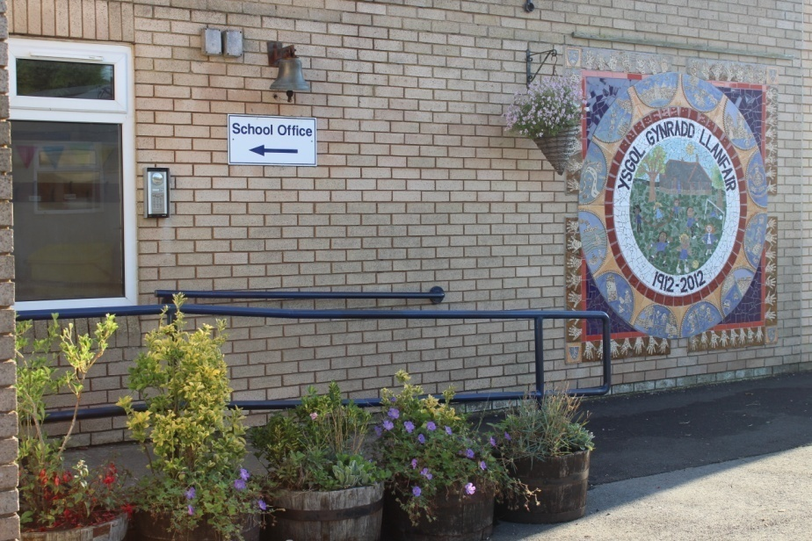

The school day is separated into a morning and afternoon session. The school session times are as follows:

Nursery: 9am – 12.00pm

Foundation Phase: Morning session 9am – 12pm
Afternoon session 1.00pm – 3.15pm

Key Stage Two: Morning session 9am – 12.00pm
Afternoon session 1.00pm – 3.30pm

School begins promptly at 9am and we expect all pupils to arrive punctually. Registration closes at 9.30am. Any child arriving after this time will be marked as absent for the morning session. Afternoon registration closes fifteen minutes after the session begins.

The external pedestrian gates are locked from 9.00am until 11.45 and from 12.00 until 3.10pm. If you require access to the school when the gates are closed please press the intercom when you reach the gates.

School term dates for the current year can be found in the appendix or at the following link:
https://www.valeofglamorgan.gov.uk/en/living/schools/School-Term-Dates.aspx

Attendance

High levels of attendance are essential to children’s academic and social development. If your child is going to be absent you must inform the school on the first day of absence, before 9.30am.

Please give prior notice to the school office of hospital, doctor, dentist, optician appointments etc.

Parents are requested to arrange their family excursions within the school holidays so that a child’s education is not disrupted.
Parents who do take their children on holiday during term-time must complete a form stating reasons for their decisions.

Pupils’ attendance is monitored carefully and parents are regularly informed of their child’s attendance rate.
For further information, please see the school’s Policy for Attendance, available from the main office/website.

Illness

Pupils should attend school whenever possible but obviously, if they are ill they should be at home.

For illnesses we use the guidelines from the Health Protection Agency to decide whether or not children and adults with varying conditions should attend school.

If a child recovering from an illness is well enough to attend school but requires medication, this should be handed in at the main office, with a completed form (available from the school office/website). Further information can be found under the medicine section below.

In cases of head lice infestation, the school takes a strict line; children be treated with the correct medication. When there is an identified case in the class, all parents will be informed via text message and are asked to check their child’s hair, treating them as necessary.

First Aid

School staff have received First Aid training and administer this accordingly. A record is kept and note is provided to inform parents. When a child has a head bump, a text message is sent to parents.

School submits incident and accident forms to the Local Authority as required.

Medicines

The school’s Healthcare Policy is available on the school’s website. This details arrangements for parents requesting administration of medicines to their child by school staff. This includes the administration of liquid paracetamol and asthma inhalers.

Please note:
• Parents must complete a request form prior to sending any medicines to the school with a child. This form is available from the office or can be downloaded from our website.
• Any medicines must be brought in a sealed, unbreakable container with clear instructions as to the dosage and when they are to be administered. In the case of certain medicines, the Headteacher might ask for GP guidance to accompany them.
• No child is to keep any medicines on their person or in their tray or bag. All medicines must be given to the Admin officer who will ensure that they are kept in a safe place, and administered at the proper times.

We always do everything in our power to ensure that the children's health does not suffer in any way, and I would ask parents to follow the above procedure. We will share information with staff regarding your child’s medical condition as required. We may also sensitively display key information in classrooms to ensure all staff are aware of your child’s condition and how to treat if necessary.

N.B.: No medicine will be administered without the above procedure being followed.

If your child is taken ill, or has an accident in school, you may be contacted via emergency telephone numbers and asked to collect.

Morning arrival and collection arrangements

We are a rural school that benefits from a large car park, however it can become congested. To ensure the children’s safety, we have several procedures in place and ask parents to support these.

We operate a drop off system in the morning. Parents can parallel stop their car on the right hand side of the car park to allow children to step onto the path and make their way onto the school yards. It remains the responsibility of parents for their child’s transfer to the school safely.

Nursery children can be accompanied to the classroom however, we encourage all of the pupils to make their way to the classrooms independently.

Please drive slowly in the car park at all times.

At the end of the school day, parents collecting only Foundation Phase pupils do so at 3.10pm when the gates will be opened. Foundation Phase pupils will be released at 3.15pm. We ask that if you are collecting only KS2 pupils that you do not enter the carpark until 3.25pm.

All parents are to vacate the car park promptly to ensure safe arrivals and departures.

If someone different is collecting your child please ensure that you inform school.

School Meals

Children from Reception age onwards stay during the lunch break. The children bring a healthy packed lunch or have a school dinner.

Big Fresh catering service provide a healthy nutritious school meal at lunchtime, which is compliant with the food and nutrient standards set by the Welsh Government.
All kitchen staff are trained in accordance with the legislative requirements associated with catering procedures, to certify that food is prepared in a protected environment.

Each day there is a choice of the cooked meal or seasonal alternative (including sub-rolls, panini, baked potatoes or soup). All served with a dessert and water.

School meals are paid through an online system called ParentPay. Parents must ensure that their accounts remain in credit by at least the cost of one meal. Details about this system are available from the school office.

The current school menu and price of school meals is available at the following link:
https://www.valeofglamorgan.gov.uk/en/living/schools/school_meals/School-Meals.aspx

Snack

Children are encouraged to bring a fruit snack for the morning break and a water bottle. Drinking water is available at all times in the main entrance.
Staff will inform nursery parents of the arrangements for snack.

Welsh Government Breakfast

The school operates a Welsh Government free breakfast from 8.00am each day. Parents that wish to use the club need to inform school and complete a registration form. Parents must sign their child into breakfast club each morning. While in breakfast club the children are provided with a healthy breakfast choice. They transfer to their classes for the start of the day.

After-school Care
An externally run after-school child care provision runs on-site.

‘At Vale Play we provide high quality childcare ensuring both child and parents are happy. Our after school club in Llanfair offers a relaxed, fun, happy environment where children can unwind after a day at school. Children are listened to, appreciated and recognised in their efforts and achievements. We promote security, self-esteem and to help children develop confidence, warm and positive relationships. Children enjoy being with other children and thrive in their company
All our staff go through vigorous checks, such as references, health, DBS and policy and procedure training. Kara Oakley and Kirsty Clarke are the Directors and Managers of the after school and also run two out of school clubs in Penarth.
You can email, phone or text for more information. We are based in the canteen part of the school and have an open door policy and welcome new families in at any time. Vale Play also have a facebook page which we update regularly. Please search ‘Vale Play’ and ‘like’ our page for regular updates.
Email Llanfair@valeplay.co.uk Phone 07955527631
We look forward to meeting you and your child.’

School Uniform

The school uniform creates a sense of belonging and a feeling of pride in the school.
We strongly encourage everyone to wear it.

- Royal Blue Sweatshirt/Cardigan with school emblem
- White or Royal Blue Polo Shirt
- Grey Trousers/Shorts/Skirt/Pinafore Dress/ Blue and white checked or striped dress
- Embroidered Navy Ski Hats are available from the school.
- Shorts/tracksuit bottoms, trainers or plimsols and t-shirt for PE. House t-shirts are available.

Please ensure that all items of clothing are clearly labelled/marked with the child's name.

Sweatshirts, cardigans and polo shirts which include the school’s emblem can be purchased from L M Sports in Llantwit Major or the Pencil Case in Cowbridge. You may, if you prefer, buy uniform of the correct colour from any retailer.

Each child is allocated one of three houses; Glyndwr, Caradog or Llewellyn. They participate as part of these houses at events throughout the year. P.E. t-shirts in House colours and printed with the House names are available from the School Office costing £7.

Jewellery
Items of jewellery such as rings, bracelets, necklaces etc. must not be worn during school time. Girls and boys with pierced ears should only wear the smallest stud ear-rings possible and these should be removed during PE and Games lessons.

Communication

We use a range of methods to communicate with parents including regular newsletters. We use a Text service to keep parents informed of activities and updates. We use Teachers2parents to send newsletters and provide hard copies when needed.
Our website is updated on a regular basis with all the latest news and information.

To adhere to GDPR we will ask for your consent to receive our emails. Further information can be found in our privacy notice on our website.

Please ensure that you alert school of any changes to your contact details.

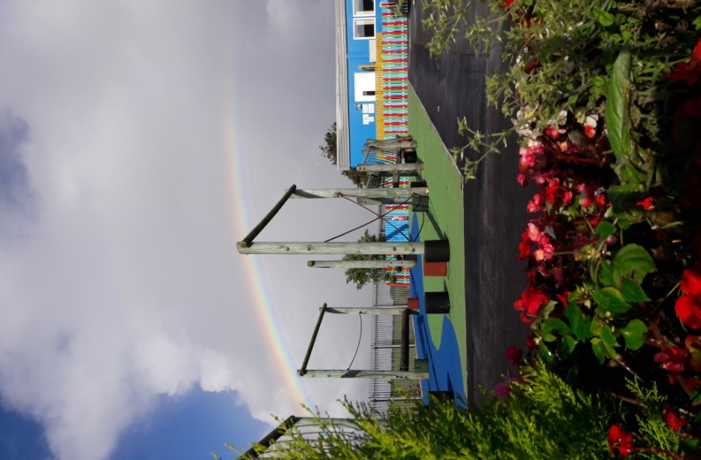

Section 4: Curriculum and Teaching

The Head teacher, Mr R Jones has ensured that a curriculum has been designed for Learning and Teaching for all registered learners from 3-11 at Llanfair Primary, in keeping with the Curriculum and Assessment (Wales) Act 2021. This curriculum will be implemented from September 2022 across all primary age ranges and will be subject to continual review, evaluation and improvement going forward.

The curriculum has been designed in such a way as to enable all learners to develop in the ways described by the four purposes:

• Ambitious, capable learners, ready to learn throughout their lives.
• Enterprising, creative contributors, ready to play a full part in life and work.
• Ethical, informed citizens of Wales and the world.
• Healthy, confident individuals, ready to lead fulfilling lives as valued members of society.

It also includes the integral skills of:

• Creativity and innovation.
• Critical thinking and problem solving.
• Personal effectiveness.
• Planning and organising.

Our School Vision sets out our rationale for Learning and Teaching with the four purposes underpinning everything that we do. The curriculum was co-constructed with governors, parents and pupils, through workshops and meetings as part of our journey towards curriculum 2022.

Our school motto ‘Enjoy, Learn, Achieve’, highlights the inclusive nature of our curriculum which is suitable for all learners of differing ages, abilities and aptitudes. It is designed to be broad and balanced and meet the needs of learners from all backgrounds
The core of the curriculum , outlining ‘what’ we teach and ‘when’ we teach it, has been designed and adopted in close collaboration with 3 other schools in our Cluster, Peterston C/W Primary, St Nicholas C/W Primary and Pendoylan C/W Primary School.
Our curriculum encompasses the Six Areas of Learning and Experience ( AOLE):

• Languages, Literacy and Communication
• Mathematics and Numeracy
• Science and Technology
• Expressive Arts
• Humanities
• Health and Wellbeing

The mandatory ‘Statements of What Matters’ have been organised into ‘Lens Concepts’ bringing clarity and definition to the distinct AOLE requirements. The ‘Lens Concepts’ ensure breadth and balance. They acknowledge the sequential and hierarchical nature of subject disciplines and the need to plan progressively in order to deepen learning.
The knowledge and skills required to deliver each of the ‘What Matters’ statements/ Lens concepts are mapped out in year groups to ensure continuity, progression and increasing levels of challenge. Suggested ‘experiences’ are also plotted across year groups to avoid duplication and ensure high levels of enrichment as pupils progress across the Primary age range.
Our ‘what’ elements of the curriculum include provision for the mandatory cross-curricular skills:

• Literacy - develop listening, reading, speaking and writing skills.
• Numeracy - be able to use numbers and solve problems in real-life situations.
• DCF - Be confident users of a range of technologies to help them function and communicate effectively and make sense of the world.

The mandatory requirements concerning Relationships and Sexuality Education (RSE) and Religion Values and Ethics (RVE) have been included in our curriculum design. The RVE curriculum has been incorporated into our Humanity Lenses. RSE will be timetabled and taught across the year through health and wellbeing focus weeks.

Welsh, though incorporated into the ‘Languages’ element of LLC, will also continue to be taught discretely guided by the CSC Scheme of Work. Modern Foreign Languages will continue to be taught as part of the Years 5 and 6 curriculum, as well as being addressed through LLC.

The Lens Concepts and What Matters Statements outline ‘What’ needs to be taught and the knowledge, skills and experiences and ‘descriptions of learning’ provides practitioners with a guide as to ‘What and When’ to teach the elements of the curriculum. The next part of our curriculum is ‘How’ it is going to be delivered in terms of pedagogy and connecting learning across the curriculum.
Across our 4 schools’ collaboration we have decided upon a ‘Golden Threads’ approach; one thread per term over a two-year cycle as outlined below:
Year A:
Consequences
Connections & Communication
Power
Year B:
Change
Journeys
Competition

At Llanfair, staff will plan our ‘Learning Expeditions’ (Topics) against these golden threads, incorporating a range of Lens concepts/What Matters statements from across the AOLE. We will incorporate the 12 pedagogical principles into our delivery of the curriculum and ensure that our expeditions are enquiry based, set in authentic contexts for learning and include pupil voice in their planning.

Assessment and Progression:
The Lens concepts, knowledge and skills ladders, as well as the descriptions of learning, underpin the medium term plans to ensure that all pupils are moving progressively along the 3-16 continuum. In doing so they will be fulfilling the 4 Principles of Progression:

Principle 1 – Increasing effectiveness – seek appropriate support, self-evaluation, identify next steps in learning and self-regulation.
Principle 2 – Increasing breadth and depth of knowledge
Principle 3 - Deepening understanding of the ideas and disciplines within the Areas – disciplinary learning.
Principle 4 - Refinement and growing sophistication in the use and application of skills.

Pupils will be taught through their ‘stage not age’. Teachers will be required to consider the knowledge and skills /progression steps above or below their age groups to ensure that work is differentiated to meet the needs of each individual pupil. ‘Assessment for Learning’ will be central to this assessment approach and quality provision will be made within lessons for target setting/success criteria and self & peer evaluation.

Teachers will keep formative records and evaluations of pupils’ progress which will be presented at ‘Pupil Progress Meetings’ with Senior Leaders throughout the academic year.
Summative Assessments will also be used to support a pupils’ progression profile. In-house tests will include Salford Reading, SWST spelling and NFER non-verbal tests as well pupils undergoing the National standardised tests in Literacy and Numeracy.

From September, the school will pilot a ‘Comparative Judgement’ approach where work demonstrating the class average / above/ below will be compiled into progression step portfolios to support staff in their evaluative judgements. We will continue to administer our baseline tests on entry to Nursery and Reception, however instead of reporting results using ‘outcomes’ we will use the ‘comparative judgements’ for the class and report baselines in terms of ‘making expected or above/below expected’ development milestones/progress.

Applying the principles outlined above, the school will be able to assess the ability and aptitude of leaners in respect of the relevant Curriculum, on entry to our school whether at the beginning or during the academic year.

Assessment will be used in a diagnostic way to highlight whether learners require additional support or challenge in their learning. Teachers will use assessment outcomes to inform their future planning.

Governance:

The Headteacher and Governing Body of Llanfair Primary School, have adopted the curriculum and assessment arrangements outlined above, at the full Governing Body meeting on the 9th June 2022 .
The curriculum and current assessment arrangements will be subject to a period of on- going review and revision. Going forward any changes will be shared at termly Governing Body meetings and an updated summary will be published.

Religious Education and Collective Worship

The school uses the locally agreed curriculum for Religious Education. Christianity, Judaism and Islam are the main religions studied but during specific festivals and across other subject areas other religions may be studied.

A daily act of Collective Worship is held in school for all pupils. The themes for collective worship are broadly Christian in nature and are often based on a set of values that the school encourages within the children. The values that are planned over a two year cycle. There are five core values that the school promotes. These are:

respect, caring, honesty, perseverance, cooperation

Usually a story or video is used and the children are invited to engage in quiet reflection and join a prayer if they wish. The school also holds celebrations at various times of the year such as Harvest and Christmas.

A celebration assembly is held on Fridays. At this assembly the children are invited to explain any events they have participated in outside of school or any awards they have attained (dance shows, sports awards etc.)

Parents have the right to withdraw their child from religious education lessons and collective worship and should contact school to discuss this matter.

Welsh
Welsh plays an essential part in preparing our pupils for living and working in Wales and is an integral part of the National Curriculum. We aim to promote a strong Welsh ethos and provide enriching activities that make learning Welsh enjoyable. We also provide opportunities to celebrate and explore the culture and heritage of Wales in order to develop awareness of the special nature of our country.
Physical Education

P.E. is a compulsory element of the National Curriculum except for those pupils permanently excused on health grounds. Such cases must be supported by a medical note from your G.P. Children suffering minor ailments will be excused when parents request it, but we would greatly appreciate a brief explanation in writing.

P.E. lessons are twice weekly for all classes either in the school hall or outside. Children need to have their own P.E. Kit - T shirt (House colours are available), shorts and trainers or plimsolls (any colour). Class teachers will inform parents of their classes’ PE days at the beginning of the year.

House T Shirts are available to order from the school. Tracksuits may be worn during the winter months.

Aims: Through our teaching of Physical Education our aims for the children are to:

- Promote positive attitudes towards health, hygiene and fitness.
- Develop a sense of fair play and sportsmanship.
- Explore dance and gymnastic movement ideas imaginatively, including actions, dynamics, space and relationship.
- Organise and use equipment safely and correctly.
- Improve swimming ability and confidence in the water.
- Use common skills effectively in different types of game, adapting their technique and style to suit the needs of the game.
- Have opportunities to play against other schools in a variety of sports.

Swimming: Pupils in years 4 & 5 travel to a leisure centre for an intensive 2 week swimming course.

Relationships and Sexuality Education

Sex and relationships education is integrated into the curriculum. For younger children it will naturally arise when they question values and attitudes which concern aspects of family life, personal relationships, caring for others and growth and development. For the older pupils, lessons focusing on issues surrounding puberty and relationships will be taught sensitively. Parents are informed when these lessons are taking place

Additional Learning Needs and Looked-After Children

We are an inclusive school at Llanfair. Children with additional learning needs, including more able and talented pupils and looked-after children, are given individual attention within the classroom situation and learning provision appropriate to their needs.

Learning Support Assistants provide individual and/or group support in collaboration with the class teachers. Intervention programmes include Catch-Up Literacy, Trugs, Every Child Counts (maths). We stress the importance of involving parents at every level of their children’s education and identifying a child’s special needs at an early stage.

Mrs. Hayley Mayes is the school Additional Learning Needs and Looked-After Children Coordinator.

There is also a register for more able and talented children (MAT). The progress of these children is monitored by the MAT Co-ordinator Mrs Amy Kumar.

Service Children

If your child is classed as a Service child please ensure that you inform school as we may be able to offer additional academic and social support when required. A service child is defined as:
- A child who has one or more parents currently serving in the armed forces
- A child whose parent/s have served in the armed forces within the last six years (Veteran)
- A child whose parent/s are currently serving as Reservists.

Homework

School provides homework that is designed to support the children’s learning without being onerous.

In Nursery, homework focuses on topic work and book bags are available for parents to borrow. From Reception to Year 2 children receive regular literacy or numeracy homework and a reading book.

The reading book continues as homework in Key Stage 2. In addition, children from Year 3 to Year 6 receive a Learning Log in which topic based homework is provided.

Key Stage 2 children also receive spellings on a Monday to practise in preparation for a test on Fridays.

We also use the Welsh Government Digital Platform Hwb for completing homework tasks throughout the school.

Reporting to Parents

Parents’ evenings are held twice a year in the Autumn and Spring Terms. We hold a Tray and Display afternoon during June/July where children sit with parents and talk about their work.

Appointments are made for parents to discuss their child’s progress with the teacher. An annual written report is sent out to all parents, usually in early July.

If there are problems at any time, it is advisable to contact the class teacher immediately, rather than wait for a parents’ evening. Serious matters should always be referred to the Headteacher.

Extra-curricular activities

A range of extra-curricular activities take place throughout the year. These vary from term to term. Activities include; orchestra, netball, dance, football, chess, gardening club. Information about these activities is shared through the newsletters.
Please contact school for further information.

Music Tuition

Cardiff and Vale Music Service provide music tuition within school. Information about the current range of lessons available can be sought from school. Music tuition fees are payable direct to Cardiff and Vale Music Service.

Section 5: Safeguarding and Site Security

The safeguarding and wellbeing of our pupils is paramount. The school has a comprehensive Safeguarding Policy which is available from the school and on our website. The school fulfils its legal duties and liaises with external agencies as necessary. All staff receive annual training in Safeguarding which covers Child Protection. Our Designated Senior Person is R Jones. Miss H Jones and Mrs. H. Mayes are our Deputy Senior Persons.
Our Safeguarding Governor is Mrs. M. Nelson.

During the school day the pedestrian gates are locked. The classroom buildings are opened using a key fob system.

School adheres to the local authority’s Safer Recruitment Policy.

Discipline and Behaviour

At Llanfair Primary School we believe that children attend our school to develop not only their academic skills but also their social and emotional skills. Learning how to manage their behaviour, responses and actions is part of this learning. We want our children to develop many attributes; however we identify the following as the core values:
respect, caring, honesty, perseverance, cooperation
Our rules underpin the development of these values. There are three to aid the recall of these rules by all school community members and to allow reference to the rules when discussing behaviour with children.

Be ready, Be respectful, Be safe

We aim to recognise children that adhere to the school rules. There will be times where children will fail to adhere to the rules and a tier of consequences exists for these occasions.

If on the rare occasion an incident is of a more serious nature, the parents will be informed in order to enlist their support in dealing with the matter.

Further information can be found in the school’s behaviour management policy available on the school’s website.

Section 6: Additional Information

Parental Involvement

Several volunteers are involved with various activities in school and their contribution is invaluable.

If at any time you wish to offer your help, please contact the Headteacher as your support is always much appreciated.

In order to comply with current requirements, all adult helpers are subject to the Safer Recruitment Policy and associated checks and references.

Parent - Teacher Association

Llanfair Primary School has a very active P.T.A. that organises many fund-raising activities throughout the year and raises a great deal of money for purchasing items needed by the school.

All parents are most welcome to get involved and their support is much appreciated. A particular welcome is always extended to new parents.

Details of PTA meetings are published in newsletters and the PTA has a Facebook page.

Charging for School Activities

All activities offered wholly or mainly during normal teaching time are available to every pupil, regardless of their parents’ ability or willingness to help meet the cost. No charge will be made for the cost of teaching materials, books or other equipment.

The school retains the discretionary right to charge for optional extras involving individual tuition, e.g. music lessons.

The school also reserves the right to invite voluntary contributions in support of the cost of providing any activity organised by the school, whether during or outside school hours. Where an activity is dependent on a sufficient level of contributions, the school has the right to cancel the activity, if insufficient support is received.

The school retains the right to request parents to pay for the cost of damage or loss caused by their child.

Classes are taken on visits that are of educational and social value to the children.
This ranges from visits to museums, industry, castles and other places of historical interest to attendance at an outdoor pursuit residential, swimming and leisure activities. Due to the location of the school we always need to charge for coach hire.

Further information can be found on the website in our Charging and Remission Policy.

Equal Opportunities Statement

Llanfair Primary School is fully committed to equality of opportunity in education. At Llanfair Primary School, discrimination of any kind and on any basis is unacceptable.

It is the policy of the school to ensure equality of opportunity for all its pupils, parents, employees and governors, irrespective of race, ethnicity, nationality, colour, cultural background, language, religious beliefs, gender, marital or parental status, social class, sexual orientation, disability, age, HIV or AIDS status and any other grounds or conditions which cannot be shown to be justifiable.

Complaints Procedure

Occasionally there may be times when you have a concern or issue that you wish to raise. We would welcome the opportunity to deal with this matter and ask that you contact school as soon as possible. A parents’ first point of contact is the classteacher.

A copy of the full complaints procedure is available from the Headteacher and on the school website.

