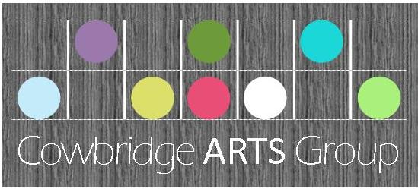

17th May 2019
Dear Parent,
Year 3/4 will be taking part in this year’s
“Selfies” Art Exhibition in the Old Hall, Cowbridge June 2019
This is a biannual event when two Primary Schools from around Cowbridge select a class/group to create about thirty self portrait drawings/paintings which are exhibited in the Old Hall gallery throughout June.
It is organised by the Cowbridge Arts Group (CAG), a voluntary non-profit making group which organises all exhibition in the Old Hall throughout the year, and whose aim is to promote the work of local artists and provide exhibitions with prizes for local schools and Cardiff and Vale College.
CAG will provide Llanfair with the paper and once complete, will frame and display the artwork in Old Hall gallery. CAG will award three prizes to pupils from each school at a ceremony at the Old Hall attended by the Mayor of Cowbridge. (Date to be confirmed)
The framed pictures can then be bought by parents for £10 each, delivered to the schools after the exhibition. All monies collected are used by the CAG fund to purchase the frames, provide prizes and to improve the exhibition facilities in Old Hall Cowbridge.
This week, the pupils have been working hard on their ‘Picasso’ style self-portrait entry and their final pieces were collected today by Mr Andy Lloyd (Chairman of CAG). Good Luck to everyone!
If you have any further questions, please do not hesitate to contact school.
Many Thanks
Mrs Sarah Trigg

