Resource | Welsh format | English format
Parent/carers and those supporting CYP with ALN.

- Jargon buster an Information, Advice and Guidance booklet for parents /carers | 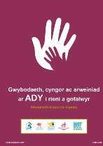  PDF document | 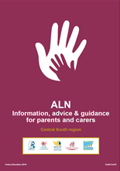  PDF document
- A3 - Parent information poster ALN step by step guide to appeals | 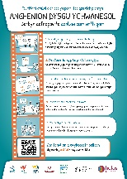  QR code on poster links to parent guide animation video | 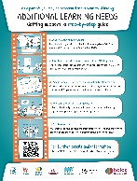  QR code on poster links to parent guide animation video
- Whiteboard animation - Parent /carer Guide to ALN support | YouTube link  https://youtu.be/z9633ZL9zls | YouTube link  https://youtu.be/ISba05AGqJk  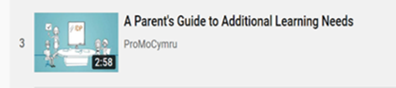
Resource | Welsh format | English format
Children and young people

- A3- CYP information poster | 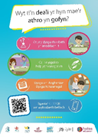  QR code on poster links to CYP animation (struggling in school) | 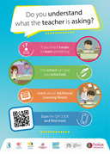  QR code on poster links to CYP animation (struggling in school)
- Animation video – information supporting Children and young people (CYP) to seek advice if struggling in school/college. | YouTube link  https://youtu.be/RT1y2pqSYhA  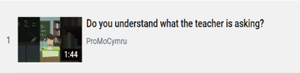 | YouTube link  https://youtu.be/Dst2Gs-tzp0
- A3- CYP information poster SENTW | QR code on poster links to CYP SENTW animation (tribunal process)  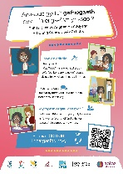 | QR code on poster links to CYP SENTW animation (tribunal process)  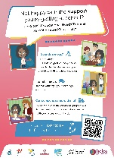
- Animation video – information supporting Children and young people (CYP) of the role of SENTW | YouTube link  https://youtu.be/d53YS4wQuBA  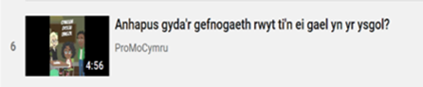 | YouTube link  https://youtu.be/8lgj3Wm5R5I  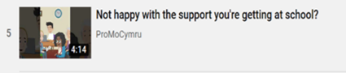
To access all video clips at once please use the following link:
https://www.youtube.com/playlist?list=PLhSmMGgX6cin37FQS9NAbYSx6xrOTvEF4

