The 3 boxes below are the focused activities for nursery pupils this week.
Please take some pictures and upload them to your Hwb account so that you can share what you have been doing with us!
Hide and Seek Pig  - Read/listen to Hide and Seek Pig by Julia Donaldson. There’s a separate video of Mrs Kumar reading the story if you don’t have a copy of the book at home.  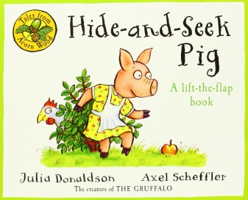  - Play Kim’s game using farm animal toys. Place around 6 or 7 toys on a tray and have a good look at them all, then cover the toys, take one thing away and ask your child to spot which one is missing. You can add more items the better they get at it | Sound of the week – ‘s’  - Say the rhyme as you write – slither down the snake  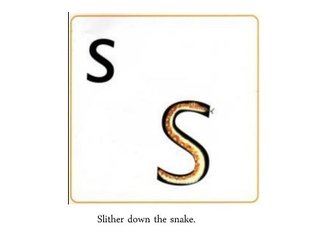  - Could you find some things around the house to make a ‘s’ shape? Maybe you could use Lego, blocks, string….see what you can find! | Mathematics  - Play hide and seek with someone at home. Make sure you practise counting really carefully to 10 each time  - Use a bucket (they called it a ‘pale’ in the story) and fill it with as many cuddly toys as you can. How many did you manage to fit in? Count them carefully, it may help to put them in a long line  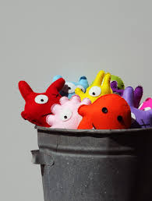
The 3 boxes below are some suggested extra activities to complete.
Please take some pictures so that you can share what you have been doing with us!

Knowledge and Understanding  - In the story, Rabbit is hiding in a tent. Can you make a tent or a den at home, inside or outside?  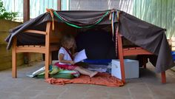 | Imaginative Play  - At the end of the story the animals enjoyed a picnic. Can you set out a picnic for some of your toys at home? You could lay out cups and plates for each person, and some food | Finger Gym  - Ask a grown up to help you make a small washing line.  Can you peg some small items on the line – socks, hankies, tea towels? Pegging is really good for strengthening small fingers, preparing them for writing  