Please do as many or as few of the activities suggested below.
Please take some pictures and upload them onto Hwb so that we can see what you have been doing!
Have a lovely Christmas!
Christmas Literacy  - Play Kim’s game using Christmas items. Place around 6 or 7 items on a tray and have a good look at them all, then cover the items, take one thing away and ask your child to spot which one is missing. You can add more items the better they get at it  - Share your favourite Christmas stories – you could draw a picture of a favourite character or part of a story | Sounds of the week – ‘c’  - ‘C’ for ‘Christmas’  - Say the rhyme as you write – curl around the caterpillar  - Practise forming the letter in sand, shaving foam, glitter…  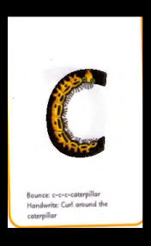 | Mathematics  - If you have a stocking (or you could use a big sock) can you count out 10 of your toys to put in it? If you are really good at counting 10 items, maybe you could add some more – up to 20 toys. Putting the toys out in a line might make counting them easier.
Creative Development  - Enjoy cooking together - bake some Christmas treats at home  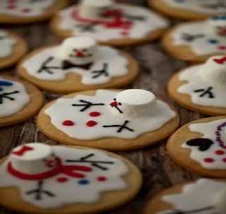 | Imaginative Play  - Can you throw a party for your teddies? Can you make sure they all have a plate and a cup, maybe balloons if you have any? Perhaps you can put some party music on and show them how to dance. You could make them party hats and eat party food too. | Physical Development  - Use the link below to join in with some yoga with a Christmas twist!  https://www.youtube.com/watch?v=pMeKIAEpWxw

