The 3 boxes below are the focused activities for nursery pupils this week.
Please take some pictures so that you can share what you have been doing with us!
Book of the week – Sports Day at Blackberry farm  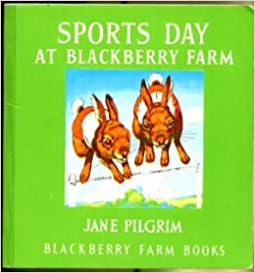  - Read/listen to Sports Day at Blackberry Farm. There’s a separate video of Mrs Kumar reading the story if you don’t have a copy of the book at home.  - Talk about what happened in the book. What races did the animals have? Which animal won the egg and spoon race? Which animals were good at rolling? Why was Christopher given a special prize? If you were at Blackberry Farm, what race would you like to do?  - Watch the song ‘The Hare and the Tortoise’. Talk about what happened. Who do you think will win the race? Who won in the end? Why?  https://www.youtube.com/watch?v=WF8iaqRqI60 | Sound of the week – ‘m’  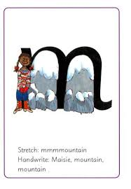  - Say the rhyme as you write – Maisie, mountain, mountain.  - Have a sound race. This can be done inside or outside. Stand at one end of a room and have some sounds written on paper at the other end of the room. Ask a grown up to call out a sound. Run and collect the correct sound. How many did you know? If you have letter magnets you could race to put sounds on a magnetic surface.  - Play sound splat. Write some sounds on separate pieces of paper. Ask a grown up to call out a sound. Try to ‘splat’ the correct sound with your hand as quickly as you can. You could play splat with someone else in your family and have a race to splat the correct sound first!  - Watch Alphablocks ‘m’.  https://www.youtube.com/watch?v=LqMPbs2KUEI | Mathematics  - Talk about ordinal numbers (1st, 2nd & 3rd). Can you remember them from our boat week? Use these terms when having races with your family. (See the extra activity boxes below)  - Look at 3D shapes – cube, cuboid, cone, sphere and cylinder. What do they look like? How many sides do they have? Can you spot any flat faces? Can you spot any curved faces? Have a look at the PowerPoint (saved separately).  - Watch this 3D shape song and talk about what the shapes look like.  https://www.youtube.com/watch?v=guNdJ5MtX1A  - Have a 3D shape hunt around the house. What 3D shapes can you find?  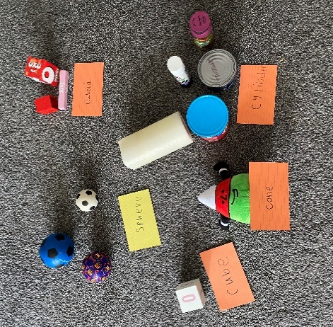
The 3 boxes below are some suggested extra activities to complete.
Please take some pictures so that you can share what you have been doing with us!

Physical Education  - Have your own family sports day! Can you race against your parents or brothers and sisters?  - What races will you create? You could have a running race, a dress up race, an egg and spoon race or even a water race! We would love to see some of your races.  - Have a look at the videos of the sports day races that we have been enjoying at home.  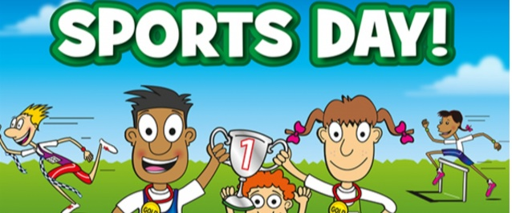 | Creative Development  - Talk about keeping healthy and eating healthy foods  - Can you make a healthy drink or snack to have after your sports day? Remember to help your grown-ups with any measuring or weighing that you need to do. Take a picture and show us what you have made.  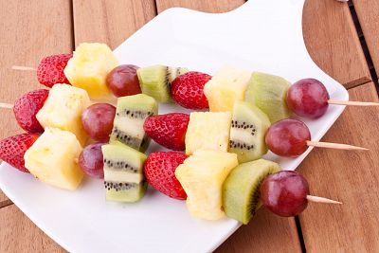  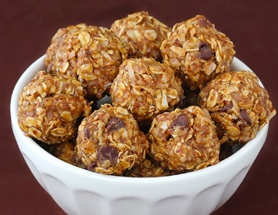 | Creative development  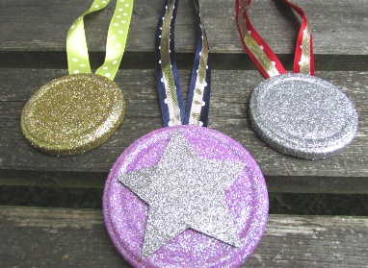  - Can you make a medal for the winners of your races? You could make a medal for 1st, 2nd and 3rd place. You could make a medal to give to someone you love instead if you want. Be creative and use whatever you like to make your medal. Here are some pictures to give you some ideas  