The 3 boxes below are the focused activities for nursery pupils this week.
Please take some pictures so that you can share what you have been doing with us!

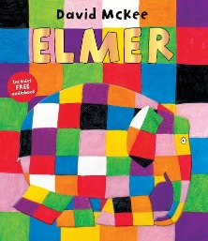  Book of the week – Elmer  - Read/listen to the book. There’s a YouTube link below if you don’t have the book at home. There are lots of different Elmer stories that you can read & listen to.  https://www.youtube.com/watch?v=wdyo4ykh2WA  - Talk about the story. Why did the other elephants like Elmer? What colours can you see on Elmer’s body? What colours/patterns would you choose if you were Elmer?  - Try to retell the story to someone in your family by using the pictures in the book to help you. | 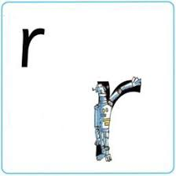  Sound of the week – ‘r’  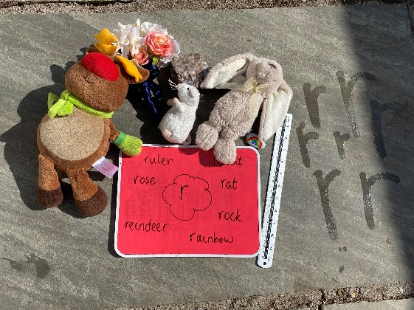  - Go on a hunt in your house for items beginning with the sound ‘r’. How many can you find?  - Practise forming the letter ‘r’ and saying our rhyme.  “Down the robot’s back and curl over his arm.” (see the video example on the website or on hwb in shared files)  You could use water and a paint brush like our picture below or you could use chalks, paints or even shaving foam! | Number of the week – 6  - Listen to and learn the number 6 song.  https://www.youtube.com/watch?v=r9qieqF2kF0  - Can you find and count 6 socks, 6 forks, 6 spoons, 6 shoes? What other items can you find? Can you count 6 items on a walk with your family?  - Watch the numtums – number 6. https://www.dailymotion.com/video/x66n5w3  - Ask a grownup to write some number 6s on pieces of paper and hide them in your house/garden. Can you find them? To make it harder they could hide other numbers too – which numbers can you recognise?
The 3 boxes below are some suggested extra activities to complete.
Please take some pictures so that you can share what you have been doing with us!

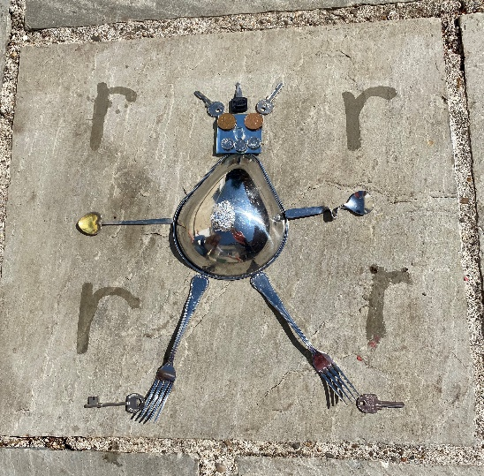  Creative  - Can you find some metal objects in your house and make a robot?  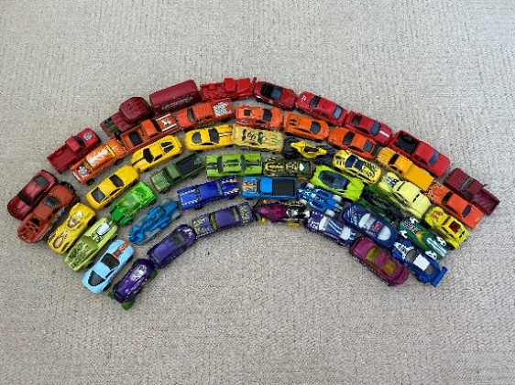  - Can you make a rainbow from colourful items? | Physical  - Can you dance along to the Awesome Rainbows song? Show your family the moves you do in school!  https://www.youtube.com/watch?v=tbPGvZDNoY0  - You could try out some of the other Go Noodle dances & exercises. There’s a link to the free website below. There is also a free app that can be downloaded.  https://www.gonoodle.com/ | ICT  If you fancy practising your computer skills, try out the mouse activities below.  http://resources.hwb.wales.gov.uk/VTC/incy_wincy/eng/Introduction/MainSessionPart1.htm

