The 3 boxes below are the focused activities for nursery pupils this week.
Please take some pictures so that you can share what you have been doing with us!
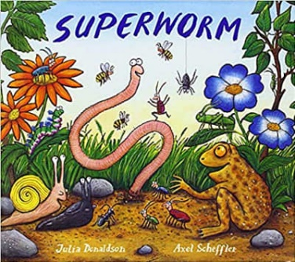  Book of the week – Superworm  - Read/listen to the book. There’s a YouTube link below if you don’t have the book at home.  https://www.youtube.com/watch?v=7Jnk3XApKBg  - Can you remember how Superworm helped his friends? How did the garden creatures help to save Superworm?  - Explore prepositions (in, on, under, over, between etc) using the worm PowerPoint (saved separately) You will need to play it in slideshow mode for it to work correctly.  - You will need a teddy and an object like a box/table/chair for this activity. Ask a grown up to use prepositions to tell you where to place your toy. E.g. Put the teddy on the chair. Put the teddy under the table. Put the teddy next to the box. Put the teddy in front of the chair.  Alternatively, there is a preposition tree game (saved separately) that you can print and play together. | 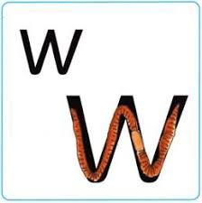  Sound of the week – ‘w’  - Practise forming the letter ‘w’. Remember to practice forming the letter in a variety of ways (with fingers, chalk, paintbrushes etc)  Remember the rhyme “Down, up, down, up.”  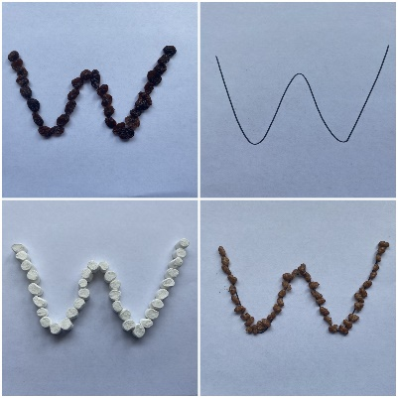  - Try making the letter ‘w’ with different items in your house. Use a ‘w’ template and put items on the lines carefully like we have below. The smaller the items you use, the better. It will help to strengthen your finger muscles.  - Watch alphablocks – the letter w. What other sounds can you see? Can you remember the sound they make?  https://www.youtube.com/watch?v=V3FOcdMtI-w | Number of the week – 10  - Sing 10 green bottles. Can you create your own song using 10 items? It could be cars, teddies or even 10 bottles if you have them! Remember to count your items each time one falls to check how many you have left. https://www.youtube.com/watch?v=Ak7kedzR8bg  - Try this worm pattern game – can you spot what comes next? http://www.literactive.com/Download/live.asp?swf=story_files/sequence_game_US.swf  - Can you draw a big worm? Can you draw a small worm? Can you draw a middle size worm? Can you put them in order from largest to smallest? Maybe you could draw a family of worms of different sizes.  .
The 3 boxes below are some suggested extra activities to complete.
Please take some pictures so that you can share what you have been doing with us!

Literacy  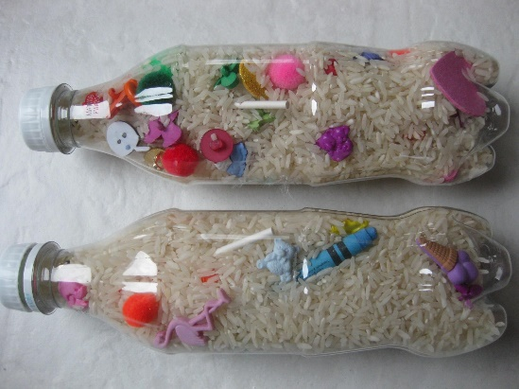  - Make an ‘I spy’ bottle. Fill the empty bottle with rice/pasta and add some small items from around your house. Use your sounds to play the game I spy. You can change the objects each week to keep the game exciting. | Physical Development  - Practice your prepositions by making an obstacle course in your house or garden. You could try climbing over some objects, crawling under objects or even running around objects. Maybe a grown up could film your obstacle course. Remember to tell us what you’re doing when you’re being filmed. (See example saved separately) | Fine Motor Skills  - Can you make a worm by wrapping wool, string or ribbon around a template? You could try making a pattern like the picture below.  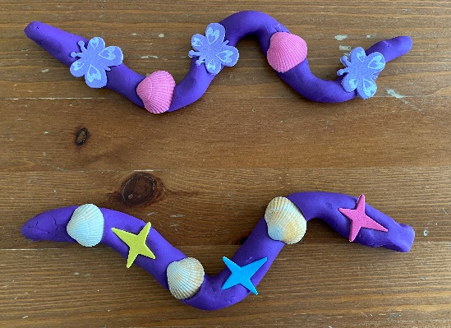  - Or if you have playdough, you could make your own worm and decorate it with items in your house. These are some we made below.  - If you would like to make your own playdough, here is a link to a quick and easy recipe below. We use this recipe to make playdough for nursery. https://theimaginationtree.com/best-ever-no-cook-play-dough-recipe/

