The 3 boxes below are the focused activities for nursery pupils this week.
Please take some pictures so that you can share what you have been doing with us!

Book of the week – We’re Going on a Bear Hunt  - Read/listen to this classic book written by Michael Rosen. There’s a YouTube link below if you don’t have a copy of the book at home. This is a great version where Michael Rosen reads the story himself with wonderful actions  https://www.youtube.com/watch?v=0gyI6ykDwds  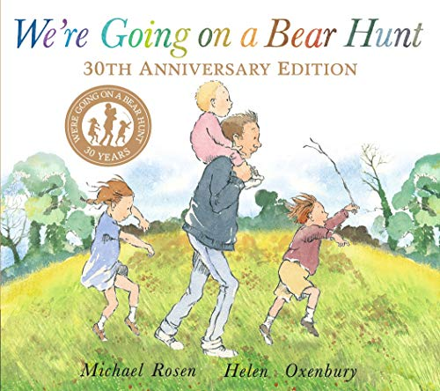  - Learn the pattern and repetition of the story – ‘we can’t go over it, we can’t go under it…’ Can you use this in your play at home, and when you go out for your daily walk? | Sound of the week – ‘b’  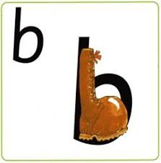  - Have a go at the letter formation - ‘Down the laces to the heel and up around the toe’  - Can you make a ‘b’ shape out of blocks? Bricks? Balls? Books?  - Take a look on Ruth Miskin’s YouTube channel. Each day a new ‘Set 1 Speed Sounds’ programme is on (but only available for 24 hours). There is a different sound each day. These are great. Send us a message if you can’t find them! | Number of the week – 9  - Watch the Numtums – number 9  https://www.youtube.com/watch?v=meTvRsaKSK0  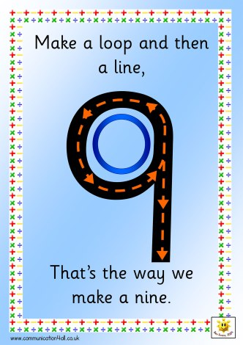  - Find as many teddy bears in your house as you can, line them all up and count them! How any do you have? Do you have more than 9 or less than 9?  - Can you find a big teddy and a small teddy at home? What about a middle sized or medium teddy that would sit in the middle in between the big one and the small one? If you are really good at ordering 3 teddies by size, try ordering 4, although this is tricky!
The 3 boxes below are some suggested extra activities to complete.
Please take some pictures so that you can share what you have been doing with us!

Creative  - Can you make your own ‘We’re Going on a Bear Hunt’ small world? You could add play people and real or pretend items to represent the grass, river, mud, forest, snowstorm and cave  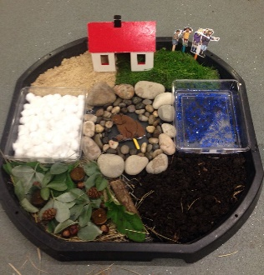  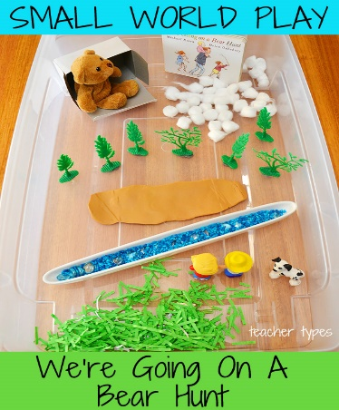 | Physical  - Follow the link below to enjoy Cosmic Yoga ‘We’re Going on a Bear Hunt’  https://www.google.com/search?q=cosmic+yoga+bear+hunt&rlz=1C1CHBF_en-GBGB797GB797&oq=cosmic+yoga&aqs=chrome.1.69i57j0l7.5202j0j7&sourceid=chrome&ie=UTF-8  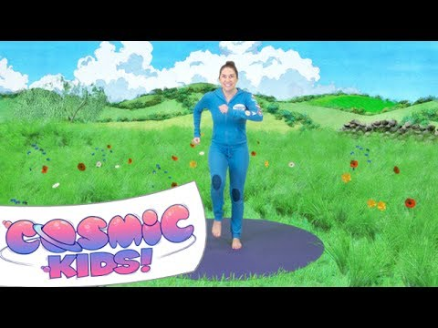 | Independence Skills  - Help a grown up to make some teddy bear toast – experiment with food that could be used to make eyes, a nose and ears  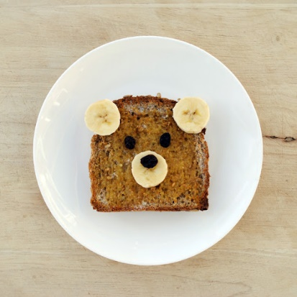  - Encourage your child to develop a comfortable tripod pencil grip, the link below has some really useful tips  https://www.youtube.com/watch?v=I06Zqcaj_E0

