The 3 boxes below are the focused activities for nursery pupils this week.
Please take some pictures so that you can share what you have been doing with us!
Book of the week – Brilliant Boats  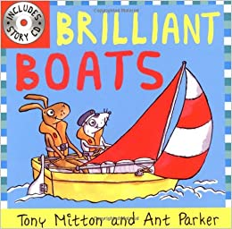  - Read/listen to the book. There’s a YouTube link below if you don’t have the book at home.  - https://www.youtube.com/watch?v=KK7Au1u-_xg  - Have a look at the different types of boats on the PowerPoint (saved separately). Talk about your experiences of boats. Have you been on a boat before? What type of boat was it? What types of boats have you seen before?  - Discuss the different parts of the boat. Can you name them? What do they do? | Sound of the week – ‘f’  - Practise forming the letter ‘f’. Try using water to form the letter. E.g. paintbrush in water, use a water pistol, use your finger to write on a steamed-up mirror or use an empty washing up liquid bottle filled with water.  Remember the rhyme “Down the stem and draw the leaves”  - You could make the letter ‘f’ out of flowers.  - How many things can you think of that begin with the sound ‘f’? Fish, float, finger, feather… You could ask a grown up to make a list of your words. Try to add to the list - you might think of more as the week goes on.  - Watch Alphablocks.- this programme focuses on CVC words (consonant, vowel, consonant). Older nursery children could practice sounding out these words using the sounds that they already know. There are plenty of these programmes on YouTube. The red level is the most suitable to start sounding out words.  https://www.youtube.com/watch?v=sWGeaFjW9GM&list=PLSW2D61TnopSJdQQM7Pi2200fnKh1CuTu&index=27&t=0s | Mathematics  - Make some boats out of foil. Test your boats in water. How many 1p coins can your boat hold? Can it hold 10 coins? Can you make it hold more than 10? If you don’t have coins, you could use beads, buttons or anything else you can find in your house. Keep counting how many items your boat holds.  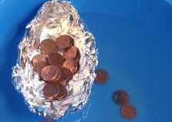  .  - Have a boat race with your family. You could use your foil boat or here is a link to make paper boats. https://www.youtube.com/watch?v=1wu5oKy4m5s  Blow your boats across the water. It could be in a paddling pool or even the bath. Who came 1st, 2nd and 3rd? Discuss the meaning of the terms 1st, 2nd and 3rd. You could make labels to show the order the boats finished. You could even make a medal for the person with the winning boat – see task idea in the box below!
The 3 boxes below are some suggested extra activities to complete.
Please take some pictures so that you can share what you have been doing with us!

Knowledge and understanding of the world  - Explore floating and sinking. What do the terms ‘float’ and ‘sink’ mean? Collect some items from around your house. Do you think they will float on the water or do you think that they will sink? Test your items. Let us know what you found out.  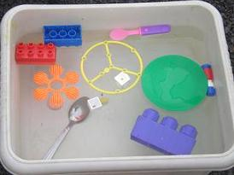 | Welsh  - Have a look at the weather PowerPoint (saved separately). Do you remember the weather in Welsh? Have a go at repeating some of the Welsh phrases.  - How would the boat that you made move in a storm? How would it move on a sunny day?  - Can you record a message or share a video with us on J2e telling us what the weather is like in Welsh?  - Have a look at the book Tedi Twt a’r Tywydd. Maybe you can join in with some of pages.  https://www.youtube.com/watch?v=FlH9-DWKj2Q | Creative development  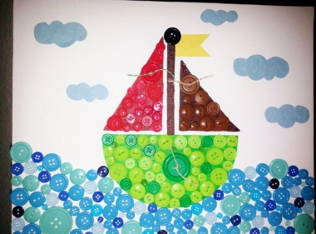  - Can you draw or paint a boat? Which type of boat will you choose? You could use your fingers to paint. You could collage your picture with paper or buttons. We would love to see your own brilliant boat.

