A Reading Guide for Parents

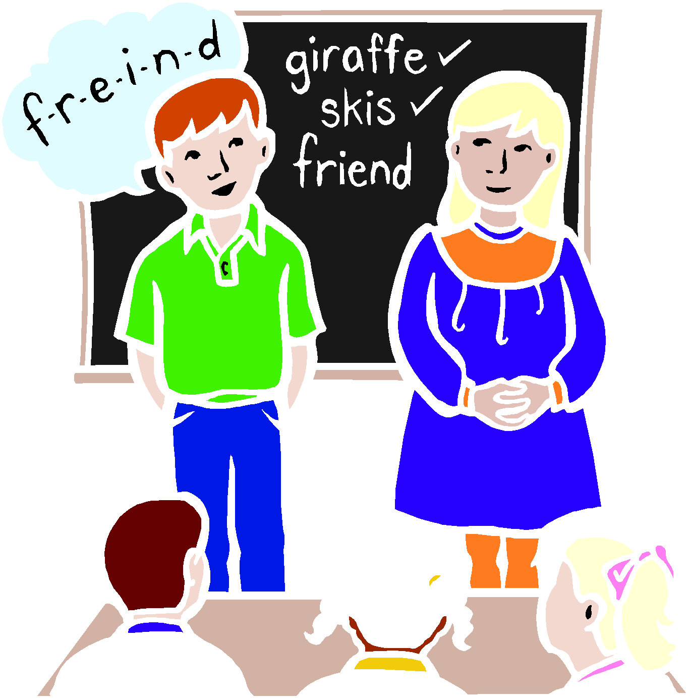

A READING GUIDE FOR PARENTS

Information for Parents
In Foundation Phase, children will experience activities such as working with words and sounds, listening and reading with an audio book, reading together, playing word games and making sentences.
In KS2, children could be reading aloud in a group, continuing comprehension activities started the previous day, summarising a passage to the rest of the group, predicting what happens next, completing a character analysis, research reading or working on a focused grammar activity. While the children are reading and discussing, they are also analysing the layout of the book and will use the good points in their own writing. Children also read on an individual basis once a week. The children read and study many children’s classics and even parts of Shakespeare’s plays. They look at a variety of poems of all kinds from different periods. Other cultures are represented by such texts as the Greek myths or traditional and modern stories from India and Africa.

SUPPORTING READING - In terms of supporting their reading at home, the children need to be encouraged to read stories, poetry, plays and all kinds of information texts. They also need to be able to choose the kinds of books that they enjoy. They may already be hooked onto a particular writer or type of book, or some may be more tuned into magazines or information texts.
READING ALOUD – As the children progress through the school, they may begin to feel that they do not need to read aloud. All children, regardless of ability, will benefit from reading to someone. It gives them the chance to read fluently with opportunity to share their book with a family member or friend. Check your child really understands the book by asking them to relate the story to you.
What can I do to help my child at Reception, Year 1 and 2?
• As well as reading aloud to someone who is listening carefully and giving help where needed, children need to talk about the book and be read to themselves.
• Try to take a regular time as often as you can to read and enjoy books.
• You could read a book to your child and get him/ her to join in when he/ she can. Children can do this best with rhymes and repeating patterns of words and at the end of sentences.
• Re-read books that are familiar to your child:
 they enjoy and get satisfaction from re-reading good books. This helps to turn them on to reading and gives them confidence.
 when they know most of the words, they can then turn their attention to reading fluently and with expression
 children can read on their own without having to wait for someone to help them. This means they can do more reading which helps them to become better readers.
 when children know most of the words, they can learn about common letter strings, about forming new words from the ones they already know and about similarities and differences between words.
• Recorded books are excellent, as they can let your child experience books that he/she couldn’t manage on his/her own.
• Check your child really understands the book by asking them to relate the story to you.
• When your child reads and gets a word wrong, allow them to complete the sentence before correcting them. Children can often work out the ‘difficult’ word by understanding the rest of the sentence. You can also help your child to break down ‘difficult’ words into parts that they recognise.

What can I do to help my child at Years 3 and 4?
• If your child has not yet joined the local library and you can get to it, now is the time to join. Children need to widen their reading and to use and browse through non-fiction.
• They need to be encouraged to read stories, poetry, plays and all kinds of information texts. They also need to be able to choose the kinds of books that they enjoy. It is at around this age that children can get hooked on to a particular writer or type of book.
• There is evidence that by the time they are in Year 4, some boys may be losing interest in reading and not doing as well as girls. Some boys are more tuned into magazines, information texts of all kinds and comics. They need opportunities for this kind of reading at home.
• Libraries do an excellent job, but there is nothing like owning your own books. Having books of your own that you can go back to, talk about and swap with a friend, collect and treasure is really important. It can make a big difference to reading progress.
• Your child will be bringing books home from school regularly. He/she may not need to read aloud so that your job in helping him/her will change. Even as adults, we like being read to, so don’t give up on this.
• Audio books are excellent, as they can let your child experience books that he/she couldn’t manage on his/her own.
• Your child might benefit from reading to younger children. This gives him/her the chance to read fluently with expression in order to keep the listener’s attention. Fond grandparents are good listeners and readers too.
• Check your child really understands the book by asking them to relate the story to you. Allow your child to reread favourite stories. This will encourage them to recognise patterns in the story and new words.
• When your child reads and gets a word wrong, allow them to complete the sentence before correcting them. Children can often work out the ‘difficult’ word by understanding the rest of the sentence. You can also help your child to break down ‘difficult’ words into parts that they recognise.

What can I do to help my child at Years 5 and 6?
• Through Years 5 and 6, children will still benefit from your help and interest.
• Word games, crosswords, word searches, Scrabble and other word puzzles are good at this stage. For reading, you might think about an encyclopaedia, book of records etc. Many children of this age like collecting facts and they are improving their reading at the same time. Joke books, verses and poetry books may also be appreciated – they can be dipped into at odd moments.
• A good dictionary and thesaurus are useful to have to hand for doing homework or for browsing through. You might give your child a subscription to a magazine that reflects his/her interests. There are also junior supplements in many newspapers.
• The other side of reading is getting into and enjoying a good children’s novel. Children’s libraries, book shops and the school can help you with selection, but at this stage it is mainly your child who will choose. Try to guarantee a quiet time and space for regular reading and homework. Take an interest in whatever your child has been set to do and have an agreed time slot for doing it in. The best place to read at this age is in bed!
• Keep up with buying books (and books on CD).
• This stage is important for your child as a life-long reader. If he/she is interested now, it is likely that he/she will continue to enjoy reading, with all the benefits that it brings.

How can I support my child as a reader?
•Read familiar books and make sure your child sees you reading (In particular dads, granddads, brothers etc. Children often see mum picking up a novel but not dads–the boys need role models!!)
• Use CDs of favourite stories and songs
• Tell stories to each other
• Place labels around the house, e.g. James’ sock drawer etc.
• Talk about your plans
- Look and find words written all around, e.g. TESCO – every little helps!

Experimental Reading:
· Talk about the characters, plots and settings of stories
· Draw attention to the print on jars, packages etc.
· Write a shopping list together
· Write messages on a message board
· Retell stories from the pictures in books

Early Reading:
· Read to your child every day
· Talk about what might happen next
· Find books in libraries and book shops
· Look at a T.V. guide together
· Encourage your child to retell stories

Transitional Reading:
· Read humorous books and books that have been made into films
· Help your child to think of a word which would make sense when he/she becomes stuck
· Plan a cookery session using a simple recipe from a cookery book
·Find an interesting article/photo in a newspaper and encourage your child to tell you about it
· Look at weather forecasts together

Conventional Reading:
· Ensure your child is exposed to wide range of reading
· Encourage your child to read for different purposes
· Take an interest in books written by favourite authors
· Support your child’s school research
· Collect newspaper articles and identify key words

…And, above all else, give lots of praise and encouragement to your children for the things they do well.

Many Thanks
Miss H Jones and Mrs H Mayes (Leaders of Literacy )

