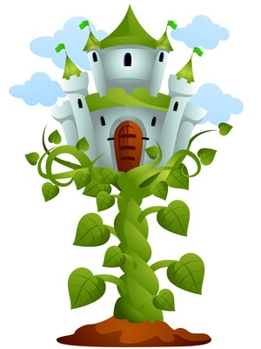

Dear Parents,

Happy New Year! Welcome back to an exciting Spring term in Year 1!

This term’s topic is 'Pop-Up’ and we have many exciting experiences planned; please find overleaf a brief overview of some of these activities. The role-play area is being transformed into a ‘Storytelling area’ and the children will work together in the making of props and posters to aid their play.

**Reading**

A reminder that your child’s reading day is ……………………………………………………

Please send in your child’s reading folder into school on this day. Occasionally, your child will take home one book provided by a teacher and a second book of their choice from a selection appropriate for their reading ability.

If your child has completed their books before the designated reading day and you have written a comment on their reading card, they will be able to take another book of their choice home.

**PE**

Our PE days are **Tuesday and Wednesday**. Please send PE kit, labelled with your child’s name, into school on these days (shorts/jogging trousers, t-shirt and trainers). If you would prefer, you are welcome to send in a labelled bag of PE kit to be kept in school for the half term.

If there is any reason why your child should not be participating in P.E. lessons (due to illness/injury) please inform school in writing.

Thank you in advance for your support.

Please do not hesitate to come and see me if you have any queries or problems.

Mrs Sarah Trigg

In this topic pupils will have the opportunity to look at pop-up mechanisms. They will look at a range of pop-up books, experiment with the mechanisms and create their own pop up invitation for a fairy tale party. During our literacy lessons, linked to this topic, pupils will learn how to write and re-tell a range of traditional fairy tales.

To start our new topic we would like to invite parents/grandparents into school to share their favourite fairy tale with the class or a group of children on Monday 18th January 2016. Please let us know if you would be willing to participate in this activity.

We will finish our topic with a fairy tale party where pupils will have the opportunity to dress as their favourite fairy tale character and take part in a range of exciting activities throughout the day. (Details of activities to follow)

If you have any stories, pop-up books or items that you feel would help resource our project, we would be very grateful if you could send them into school with your child.