Autumn Term - 2019 (Year 3/4) 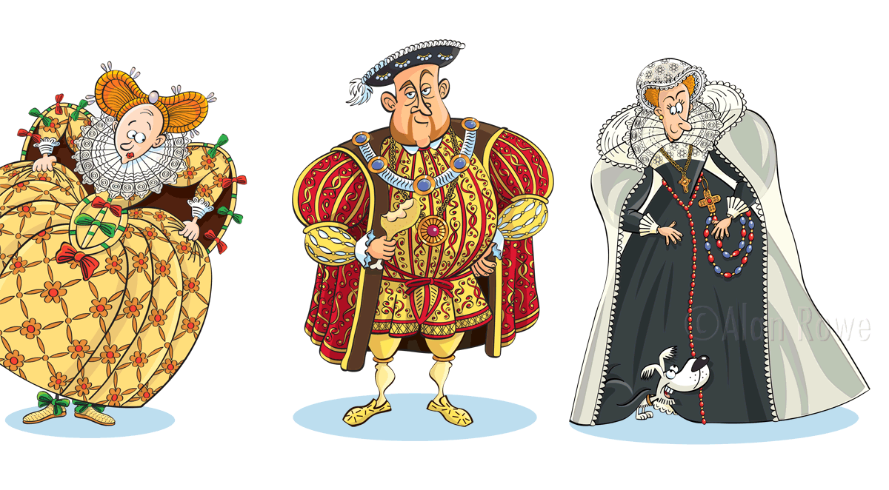

Dear Parent,
Firstly, I would like to welcome everyone to the new school term. The children have all settled in well to their new classroom routines.

This term’s topic is 'The Terrible Tudors’ and we have many exciting experiences planned.

Reading – Year 3
Starting from next week, your child’s reading day will be ……………………………………
Please send in your child’s reading folder into school on this day. Your child will take home one book provided by teaching staff and a second book of their choice from a selection appropriate for their reading ability. Each child will have a reading record card with a comment from the teacher and a space for you to make a brief comment also. These books need to be returned to school with reading books on a weekly basis. In January, Year 3 will move on to the KS2 Guided Reading scheme.

Reading – Year 4
Year 4 children will continue with the KS2 Guided Reading scheme. However, if you would like to do extra reading at home, please let me know and I will send home one book with a reading card which can be exchanged once read.

Spelling
The children will bring their spelling book home to practise words each Monday. Please return the book on Friday of the same week for testing.

Homework
In KS2, all homework is recorded in a ‘Learning Log’. At the start of each half term a ‘Homework grid’ linked to our topic will be stuck into their Learning Log. Each week, your child must complete one activity from one box on the grid. Learning Logs will be handed out every Friday and are due back by the following Wednesday. Please ensure that a pencil is used to complete this work and that pens are only used for colouring activities. Information can be typed but please do not ‘cut and paste’ directly from the internet.

P.E.
Sessions will be every Tuesday and Friday. Please ensure that your child’s name is clearly marked on all their items of clothing. If there is any reason why your child should not be participating in P.E. lessons (due to illness/injury) please could you let me know.
Thank you in advance for your support.

Mrs Sarah Trigg

Class Teacher

