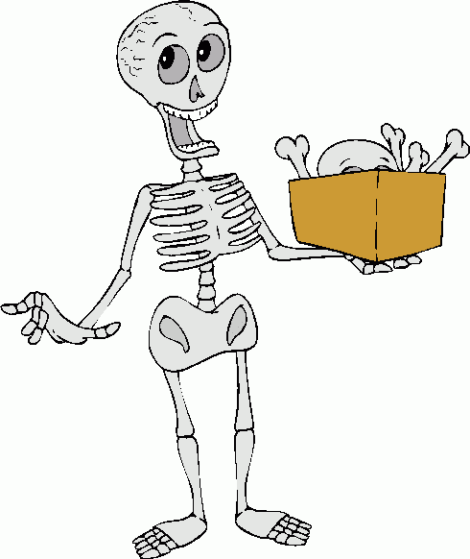 Autumn Term - 2017 (Year 3/4) 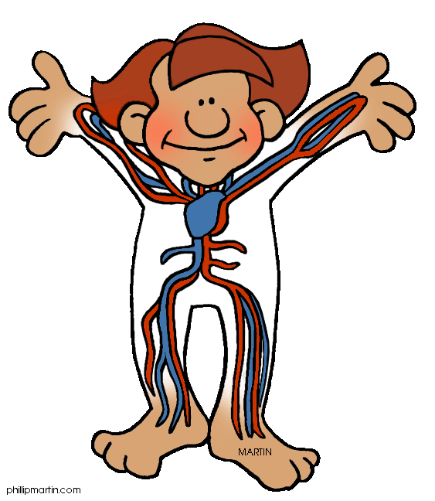

Dear Parent
Firstly, I would like to welcome everyone to the new school term. The children have all settled in well to their new classroom routines. This term’s topic is 'Bones, Blood and Gory Bits’ and we have many exciting experiences planned.

Reading
Starting from next week, your child’s reading day will be ………………………………………………….
Please send in your child’s reading folder into school on this day. Your child will take home one book provided by teaching staff and a second book of their choice from a selection appropriate for their reading ability. Each child will have a reading record book or card with a comment from the teacher and a space for you to make a brief comment also. These books need to be returned to school with reading books on a weekly basis.
If your child has completed their books before the designated reading day and you have written a comment on their reading card/book, they will be able to take another book of their choice home.

Spelling
The children will bring their spelling book home to practise words each Monday. Please return the book on Friday of the same week for testing.

Homework
In KS2, all homework is recorded in a ‘Learning Log’. Each week a research task linked to our topic will be stuck into the log. For extra information, I have provided an example from last year. ‘Learning Logs’ will be given out on a Friday and are due back by the following Wednesday. Please ensure that a pencil is used to complete this work and that pens are only used for colouring activities. Information can be typed but please do not ‘cut and paste’ directly from the internet.

Yellow Times Tables Target sheet
I have given each child a yellow slip which states the times table they are working on and what they need to practise at home. When your child is confident, please send the slip back to school for testing and a new target sheet will be handed out. If they struggle with any part of the slip, then the slip will be returned home showing which areas need further practise.

P.E.
Sessions will be every Tuesday and Thursday. Please ensure that your child’s name is clearly marked on all their items of clothing. If there is any reason why your child should not be participating in P.E. lessons (due to illness/injury) please could you let me know.

Thank you in advance for your support.

Mrs Sarah Trigg
Class Teacher

