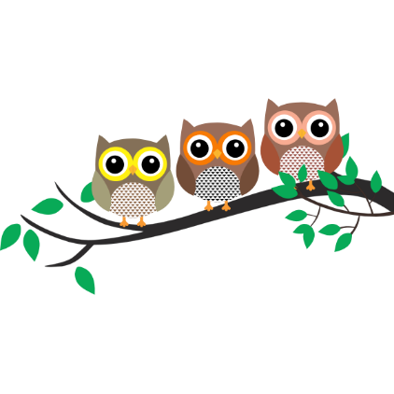

Autumn Term - 2021 Year 1 and 2

Dear Parent,
Firstly, I would like to welcome everyone to the new school term and hello to all our families that have joined us this year. The children have all settled in well to their new classroom routines and are enjoying a variety of activities both inside and outside.

This term’s topic is ‘Wonderful Woodland’ and we have many exciting experiences planned. Please visit ‘Meet the Classes’ on our website: llanfairps.com for class information and photographs.

Reading
Each week, your child will read individually or in a group and will be encouraged to improve their phonetic reading strategies, pace and fluency. Your child will bring home a folder containing two Oxford Reading Scheme books (with a comment card). This folder will be sent home on a fortnightly basis beginning Friday 24th September and must be returned to school by Friday 8th October when they will be given two new books and tasks.

Spelling – Year 2
Spellings will focus on the ‘Sound of the week’ and high frequency words. Spelling words will be sent home every Monday in a blue spelling book. During the week, your child can practice writing the words on the same page. Please return spelling books to school on Friday of the same week for an informal test. (The test will be recorded at the back of the blue spelling book).

Spelling – Year 1
Spellings will focus on the ‘Sound of the week’ and high frequency words. Spelling words will be sent home every Monday on an A4 sheet. During the week, your child can practice writing the words on the sheet in preparation for an informal test on Friday.

P.E.
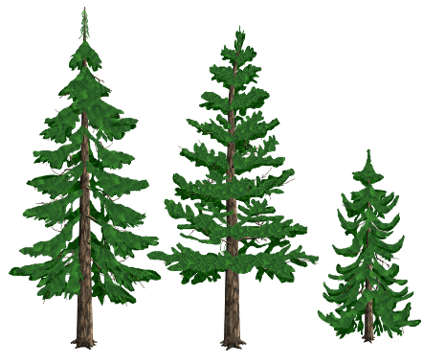
P.E. every Wednesday. Please ensure your child comes to school in their PE kit. If there is any reason why your child should not be participating in P.E. lessons (due to illness/injury) please could you let me know.
This Photo by Unknown Author is licensed under CC BY-NC-ND

Wellies
As the weather is changing and outdoor learning is getting a little
muddy, please could your child bring in a pair of wellies to keep in school.

Thank you for your support,

Mrs Sarah Trigg

Class Teacher

