Llanfair Primary School
Enjoy, Learn, Achieve
Newsletter No. 3 November 2021
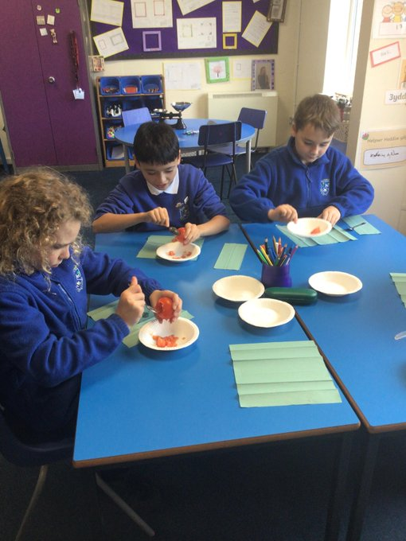
Year 6 enjoyed mummifying tomatoes as part of their Egyptian topic!
Spooks and Sparkles
Many thanks to everyone that organised and supported the spooky walk event. It was a huge success and has raised a fantastic £2322.40! This will be spent purchasing resources for the school. Diolch yn fawr iawn!
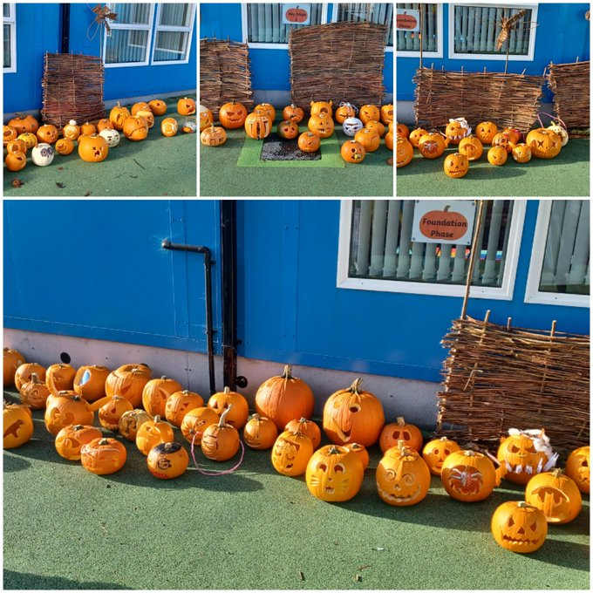
PTA News  We’re pleased to be able to announce that the PTA Cake Stall at the St Hillary Foragers Produce Market, raised an amazing £502.10.  Thank you to everyone who baked and/or helped out on the stall! The recent Bag2School collection raised £117.  The AGM will be held on Tuesday 16th November at 4.15pm via Zoom. A link will be sent out. |  | Tempest Photos  A reminder that individual school photos will be held on Monday 8th November.
Remembrance Items
To support the Royal British Legion’s poppy appeal we have poppies for purchase in school. We also have some other items for the children to purchase next week. These are zip pulls (suggested donation of 50p), reflectors (suggested donation of 50p), silicon wristband (suggested donation of £1) and snap band (suggested donation of £1.50). We would be very grateful if the children could bring the correct money in a named envelope. For items other than poppies we will be restrciting the children to one item each initally to ensure that all children have a chance to purchase. After this we will let parents know of any stock still available.
Mid-day Supervisor Roles
Sadly we will be saying goodbye to Mrs. Horton, our mid-day supervisor in the next few weeks. Mrs. Horton is moving on to a new full time post. We wish her the best of luck and thank her for her hard work at lunches and in the classrooms. We will be advertising for two mid-day supervisor positions from next week which will be available on the Vale of Glamorgan website. We would be grateful if parents could make aware anyone interesed in the the roles. Equally if any parent is interested in a relief position as either mid-day supervisor or breakfast provision, please contact school for an informal chat.
Current Operation
We continue to follow measures set out in the infection control framework and act on the advice from Cardiff and Vale Health Board and the Local Authority. We recognise that these measures may seem incongruous with the requirements in wider society but it is hoped that these school based measures contribute to reducing the spread of Covid. Information on the changes to self-isolation are available at https://gov.wales/self-isolation
Car Park
We would like to thank everyone for their patience in the car park. We are very grateful to everyone for following the guidelines.
Snack and Dinners  We encourage all children to bring a fruit snack for morning break. We also encourage all the children to bring a water bottle to school which they can refill when needed.  If your child will be late to school due to an appointment etc. please let school know if you require a school meal. | Nuts and Grapes  Please ensure that no nut based products are sent into school for children’s packed lunch as we have children and adults with severe nut allergies. Please note that this includes seseme seeds (please check any seeded bread rolls).  With young children it is recommended that grapes are cut in half length ways to avoid choking.  Many thanks.
Snack and School Meals
School dinners are available to all children and are provided by the Big Fresh Catering Company. The current menu can be found at:
https://www.bigfreshcatering.co.uk/wp-content/uploads/2021/09/Big-Fresh-menu.pdf
School meals cost £2.40 each day and are paid via ParentPay. Please ensure that your account is kept in credit by at least the cost of one school meal. Information about our School Meal Payment policy is available on our website.
Term Dates and INSET days
The following link provides access to the term dates for this academic year and the next:
https://www.valeofglamorgan.gov.uk/en/living/schools/School-Term-Dates.aspx
Contact School:
If you have any concerns or queries, please contact school. A copy of our complaints procedure is on our website.
Tel: 01446 772245
Email: Llanfairps@valeofglamorgan.gov.uk
Dates for your diary (new dates added in bold)
Nov:

8th Tempest Individual Photos
15th Stay Safe/Anti-bullying Week
16th PTA AGM 4.15pm via Zoom
19th Children in Need (information to follow next week)
22nd Road Safety Week
22nd Year 6 Parliament online session

Dec:
6th Christmas Concert Week (TBC)
10th Christmas Jumper Day
17th End of term

Mar:
1st St David’s Day and Eisteddfod
7th – 9th Year 6 trip to Llangrannog

Jun:
13th Swimming for Y4 and 5 begins for two weeks
17th Cycle Training for Y6

