Llanfair Primary School
Enjoy, Learn, Achieve
Newsletter No. 1 September 2021
Welcome back to all! It has been a pleasure to have the children back this week and they have settled very well. We have enjoyed being outdoors working (in all the varying weather we have had this week!). My thanks to Nancy Evans for her inspirational work with the children this week. The infants made a wonderful Mud Guardian on the school field.

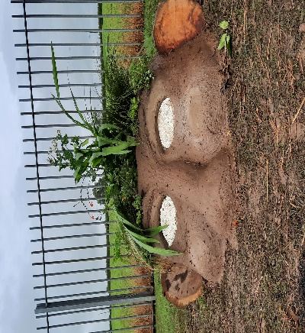

Next week we will sadly be saying goodbye to Mrs. Lianne Dunmore, our mid day supervisor as she embarks on a new career. We wish her the best of luck and thank her for her time in Llanfair.
Mr. JP. Guy
Headteacher
Current Operation
We are currently including some control measures in line with Welsh Government’s Operational Guidance (separate playtimes, slightly extended lunchtimes to reduce the number of pupils in canteen space, asking visitors on site including parents to wear a mask etc.) and some from the superseding Local Covid-19 Infection Control Framework. We have removed some other controls (key stage two pupils not sitting in rows) and our plan is that progressively we will remove further controls over the next few months and reinstate aspects of school life (extra-curricular activities etc). Certain core controls (hand sanitizing, ventilation) will remain in place throughout. A copy of our risk assessment can be found on our website.
Timings
Please note that school begins promptly at 9am. Infants are to be collected at 3.15pm unless they have a junior sibling in which case collection is 3.30pm. At this moment we are bringing some classes to the gate early to dismiss the children when we see the adult collecting them to reduce the gathering at the gate.
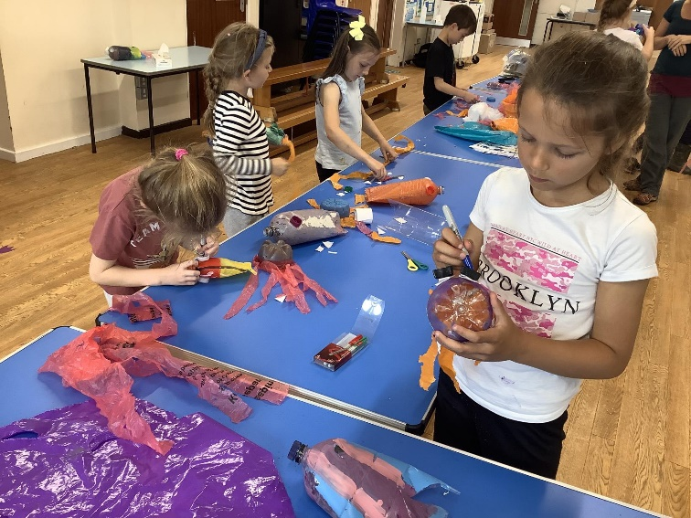
Mr. Lewis’ class made model fish to help learn about the effect of plastics in the ocean.
Building Work
Construction of the new child care building is almost complete and this will hopefully be up and running as soon as the relevant documentation is in place. There was a problem demarcating the car park last week and this is now scheduled for tomorrow. To ensure your child’s safety please abide by the following rules in the car park:
- Use the drop off system in the mornings whenever possible (parking parallel to the fence).
- Drive slowly and reverse park into spaces.
- Vacate the car park promptly at the end of the day.
We are delighted that the key stage two (junior) toilets have been refurbished. The colour schemes were chosen by the children and look great. I am grateful to the local authroity for funding this.
PTA Events
The St Hilary Foragers Produce Market will be held on Sunday 26th Sept 12-3pm on the village green. Llanfair PTA have been asked to run the cake stall, with all proceeds from the sale of cakes going to our PTA! If you are able to donate cakes, flapjack, cupcakes etc which we can sell (shop bought or homemade) then we’d be very grateful. We would also appreciate help in running the stall, even if you can only volunteer for 30mins, then that’d be fab.
Please contact the PTA if you are able to help in any way:
Llanfairprimaryschoolpta@gmail.com
Or via our Facebook Group - search for “Llanfair Primary School PTA”
More precise details about the arrangements eg how/where to drop off cakes etc, will be announced shortly.
A Bag-2-School collection (parents can donate unwanted clothing and the PTA receive a payment) will be Tuesday 21st September and information regarding this will be distributed next week.
House Points
We operate a house point collection system in school with the winning house receiving the trophy each half term. All new pupils will be allocated to one of three houses; Caradog, Glyndwr or Llewellyn. Our school rules are Be ready, Be respectful, Be safe and the children receive house points and Over and Above stickers for following these as well as for their hard work in class.
Snack and Dinners  We encourage all children to bring a fruit snack for morning break. We also encourage all the children to bring a water bottle to school which they can refill when needed.  If your child will be late to school due to an appointment etc. please let school know if you require a school meal. | Nuts and Grapes  Please ensure that no nut based products are sent into school for children’s packed lunch as we have children and adults with severe nut allergies. Please note that this includes seseme seeds.  With young children it is recommended that grapes are cut in half length ways to avoid choking.  Many thanks.
Communication
We aim to provide a fortnighly newsletter which will also include dates for your diary which is emailed out and also published on our website. Please ensure that you update us with any changes to email addresses, phone numbers and addresses.
Text messages
We use text messages to communication with parents. Please bear with us if some messages are short as we only have 160 characters to use!
Twitter
We were aiming to launch our Twitter feed this year but have come across a technical problem which we hope to resolve shortly.
Uniform  It has been great to see the children arriving in their smart uniforms. Please ensure that children’s names are marked on all items. A reminder that no jewellery should be worn except stud earrings and a watch. | PE kit  PE lessons begin next week and class teachers will inform parents as to which days these take place. We ask that at this moment the children come to school in their PE kits. A reminder that House t-shirts are available from school at a cost of £7.00 and that the children are welcome to wear these for their PE lessons. Please contact the office if you would like to purchase one for your child.
Safeguarding
Mr. JP Guy is the designated safeguarding person with Miss Jones and Mrs. Mayes as deputies.
Mrs. Margaret Nelson is the safeguarding governor.
All staff have been trained in safeguarding procedures. Should you have any concerns, please speak to the school. School adheres to its legal requirements and liaises with partner agencies as required.
Parent Governor
We have a vacacncy on our governong body for a parents governors. Letters regarding this will be distributed next Tuesday.
Snack and School Meals
School dinners are available to all children and are provided by the Big Fresh Catering Company. The current menu can be found at:
https://www.bigfreshcatering.co.uk/wp-content/uploads/2021/09/Big-Fresh-menu.pdf
School meals cost £2.40 each day and are paid via ParentPay. Please ensure that your account is kept in credit by at least the cost of one school meal. Information about our School Meal Payment policy is available on our website.
Cardiff and Vale Music Service
CCVG will be running a training choir for Years 3 to 9 on Tuesdays from 5.15pm in the Chapter Arts Centre in Cardiff. Further information can be found at www.ccvgmusicservice.org or ringing 02920872883.
Term Dates and INSET days
INSET DAYS:
Friday 1st October 2021 and Monday 4th October 2021
The following link provides access to the term dates for this academic year and the next:
https://www.valeofglamorgan.gov.uk/en/living/schools/School-Term-Dates.aspx
Contact School:
If you have any concerns or queries, please contact school. A copy of our complaints procedure is on our website.
Tel: 01446 772245
Email: Llanfairps@valeofglamorgan.gov.uk

